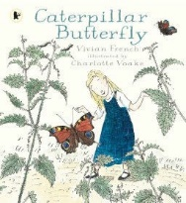

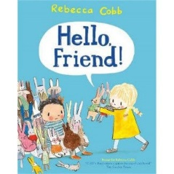Reception Reading Journey

|  |  |  |
| --- | --- | --- |
| Autumn | Spring | Summer |
|  |  |  |
| **Supporting Texts** | | |



