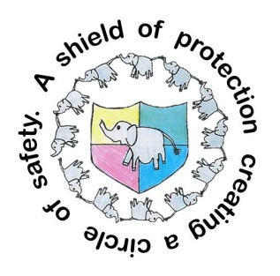
Rivington Primary School
Child Friendly Safeguarding Policy
All the adults around you think that your well-being is very important.
In our school, we respect you and everyone else and help to protect your rights.
We do our best to help you make progress in your work.
We teach you how to recognise risks in different situations, and how to protect yourself and stay safe.
We try to make school a safe place for you to learn in.
We want to make sure that you stay safe, at home as well as at school.
We make sure that you know how to keep safe when online.
We think it is important for you to know where to get help if you are worried or unhappy about something.
Need to talk? You can talk to any adult in our school, we will listen to anything you’re worried about. We will always be there for you or, if you wish you can contact 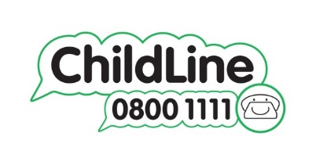
Our Child Protection Team are Mrs Powell, Miss Bibby & Miss Cunliffe.

