**Basketball Competition**

**5th March 2019**

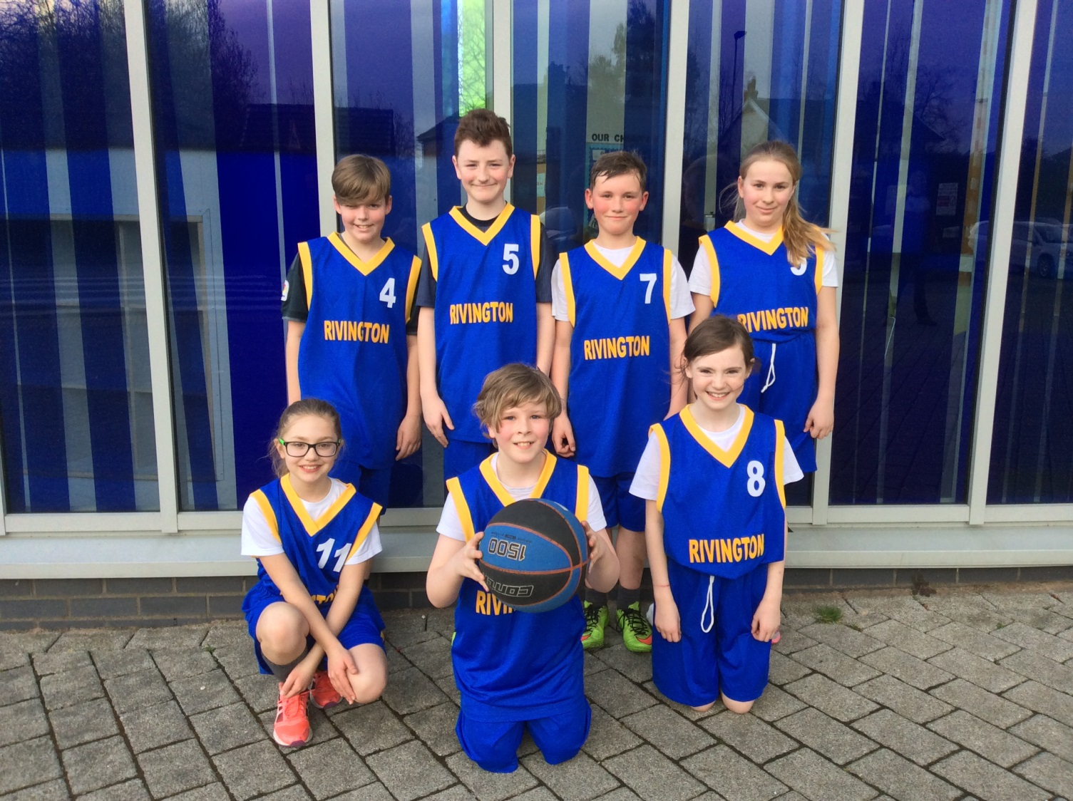

Congratulations to all the children who represented the school at the School Games Basketball Tournament at Hope Academy on Tuesday 5th March. The children showed real commitment and sportsmanship throughout the tournament and managed to progress to the final after winning all four games at the group stages.

