RIVINGTON PRIMARY SCHOOL

Healthy Eating Policy

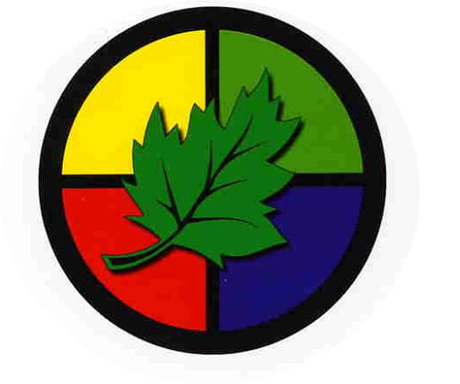

We invite you to come on an exciting learning journey.
Discover, create, invent, explore. Join the adventure …….

Update March 2015

RIVINGTON PRIMARY SCHOOL

Our School Healthy Eating Policy

Our food policy was written by the School Community led by the children in the Spring of 2006. Key Stage 2 children researched aspects of healthy eating and shared this with the school. Working in mixed age teams, the children explored the themes further, designed parents’ questionnaires and designed their own healthy school tuck shop. They also talked to experts and watched a theatre production on Healthy Living.

They presented their ideas to the whole school, staff and Governors and to parents, with a huge fruit basket containing their ideas in the entrance hall.

Firm proposals then went to class councils and school council. The following is the result of their work.
They revised this policy in 2010.

Aims

1) We want to enjoy eating
2) We want to eat food that is safe
3) We want to learn about food so that we can stay healthy
4) We need to eat more fruit and vegetables as these are good for us
5) We want to eat foods that help our world and don’t harm the environment
6) We want to have foods that let people who need or want to have special diets do so ~ e.g. vegetarians, diabetics, people with religious beliefs or allergies
7) We want to eat 5 pieces of fruit or vegetables every day
8) We want to drink more water

We need to agree to work together:

•School Governors
•All the Staff
•Children
•Parents
•Our kitchen and dining room staff
•The school’s wider community

We will do this by:

1) Having a tuck shop that sells fruit, vegetables, toast, milk and other healthy food
2) Having a treat occasionally when we can try new things.
3) We will only bring healthy fruit and vegetables to school for snacks. We will learn about foods that are healthy, grow and cook our own food.
4) We will sell food that does not leave litter and take care to put litter in the bin
5) We will try and find food that is fairly traded and does not harm the environment
6) We will all try to eat 5 portions of fruit and vegetables every day
7) We will learn about foods that are good for us to keep us fit, healthy and protect our teeth
8) We will drink more water
9) We will be sensible and not waste food

Things we do in school

Class | Activities
Nursery | - Children are provided with fruit for a snack every day.  - During snack times, children are encouraged to try healthy, new snacks. These often relate to work they have been doing.  - Parents Board showing healthy eating options.  - Life Education Bus – Healthy eating and drinking.  - Food tasting sessions when children can try healthy options.  - Making food with the children – e.g. fruit jellies.  - Role play of Handa’s Market, selling fruit and vegetables.  - Children do planting and growing and then taste the food that they have grown.  - Display – My Fruit Basket.
Reception | - Children are provided with fruit for a snack every day.  - During snack times, children are encouraged to try healthy, new snacks.  - Making food with the children – e.g. fruit jellies.  - Chinese New Year – tried different foods.  - Wholemeal toast at snack time now offered.
Year One | - Humans – Science topics – The children learnt about the importance of a balanced diet and eating their 5 a day. This was a promotion in the Doctor’s role play surgery.
Year Two | - The children researched and made a healthy lifestyles book. This included the importance of a balanced diet, water and personal hygiene.  - In the Spring term the children explore growing in terms of growing their own salad and eating this. They study which parts of a plant are edible.  - They use the work of Archimboldo to inspire fruit and vegetable collages.
Year Three | - Humans – skeletons and muscles topic, including a healthy lifestyle  - Fit4Life – 6 weeks of food and exercise lessons  - Friday treat – different fruits they haven’t tried (passion fruit).
Year Four | - Humans including animals, Science topic – digestive system. We designed our own healthy plate.  - Visitor – Anti-smoking – importance of being healthy.
Year Five | - Crucial Crew – section on healthy eating showing children the sugar content in snacks and drinks  - Ancient Greece – PE topic looking at athletics and diet  - Science Topic – Exercise and diet within topics of Humans and other animals
Year Six | - Science – The human body. We will be working at all aspects of keeping our bodies fit and healthy, including what we eat. We will look at the affects of certain foods (or too much of them) on our healthy. Healthy breakfast during SATs week and children to understand the need for a healthy breakfast to start the day to help our brains/memories.
Whole School / Joint Classes | - Year 5 and 6 – Get Closer play – a play that highlighted the importance of a healthy lifestyle, especially eating. This focused on pregnancy and breastfeeding.  - Every class held a Coffee afternoon for parents and other visitors during Book Week. Whilst enjoying the entertainment, Fairtrade refreshments were on sale. There was an accompanying information board that explained the importance of buying Fairtrade goods.  - We grow many different fruits and vegetables in our school allotment, including strawberries, potatoes, corn and peas. They are then used for taster sessions to encourage pupil to eat their ‘5 a day.’

