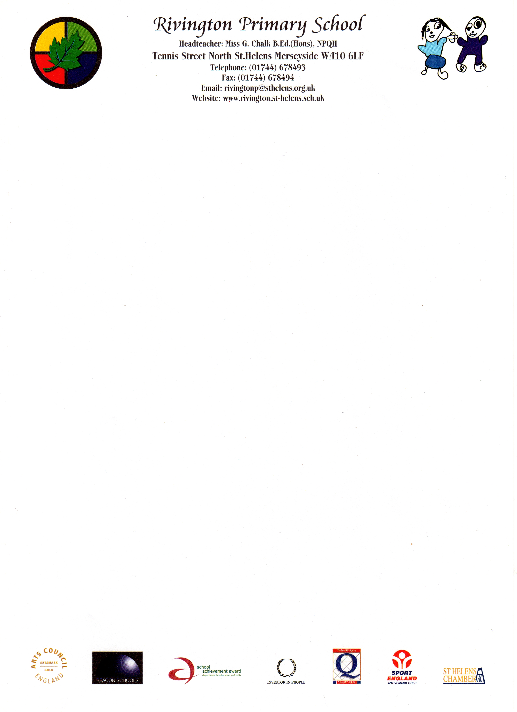
We invite you to come on an exciting learning journey.
Discover, create, invent, explore. Join the adventure …….

Governor’s Allowances Policy 2018

At the Full Governing Body Meeting held on 26th March 2017 it was proposed by

____________________________________

and seconded by

____________________________________

and unanimously voted that no member of the Governing Body will make a claim for any expenses.

Ratified To be reviewed Spring Term 2018

Chair ______________________________

Head Teacher _____________________________

