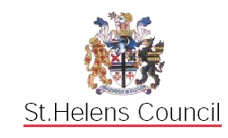

BEING THE

LOCAL EDUCATION AUTHORITY

INSTRUMENT OF GOVERNMENT: COMMUNITY PRIMARY

SCHOOL

1. The name of the school is Rivington Primary School.

2. The school is a Community Primary School.

3. The name of the Governing Body is The Governing Body of Rivington Primary School.

4. The Governing Body shall consist of:-

- 1 Head Teacher

- 3 Parent Governors

(b) 1 LA Governor

(c) 1 Staff Governor

(d) 6 Co-opted Governors

5. Total number of Governors : 12

(The Head Teacher to give written notice that s/he chooses not to be a Governor).

7. The term of office of all Governors is four years.

8. This Instrument of Government comes into effect in June 2018.

9. This Instrument was made by order of the St. Helens Council Local Education Authority on 22nd February 2005 to comply with Part 5 (Regulations 27-34) of the School Governance (Constitution) (England) Regulations 2003.

