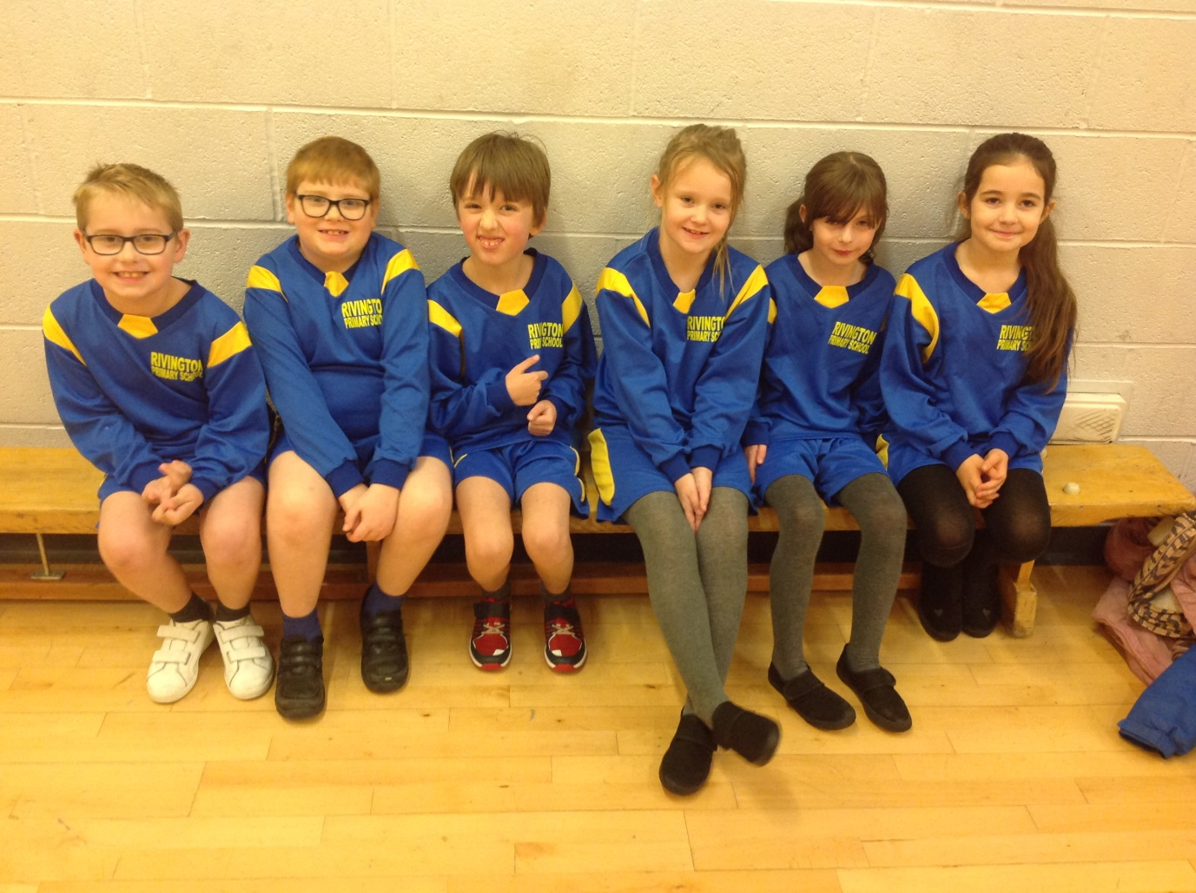
Boccia Competition
21st November 2018

On the 21st November Isla, Tilly, Kyle, Katie, Jayden and Jack all attended the annual Boccia Competition at Lansbury Bridge to compete against 32 other schools from across the borough. All pupils worked really well as a team and showed great support to team members who wanted a bit of help. All the team took part in the group stages of the competition playing 4 games, winning 2 and loosing 2. Unfortunately Rivington didn’t progress from the group stages but this wasn’t through lack of effort. Everyone had a great time and represented the school with pride, well done to you all.

