Year 6 Everton Football Tournament
1st October 2018

A huge congratulations to our Year 6 football team who came second in the Y6 Everton Football Tournament at Ruskin Drive on Monday 1st October 2018. The team made the school proud with their performance throughout the tournament and played incredibly well together, showing great enthusiasm and teamwork. The team came a close second in the tournament after achieving the same amount of points as another school and the winner being determined by goal difference.
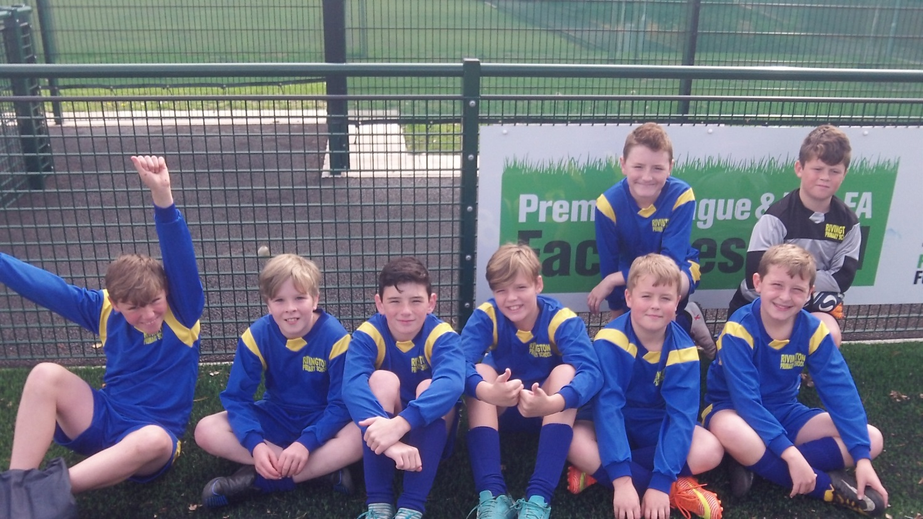

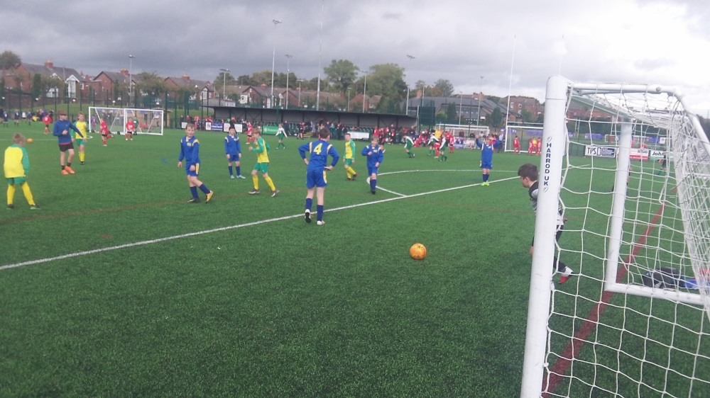
The ‘Player of the Tournament’, which is voted for by all the players in the team, went to both Matthew and Harrison today.
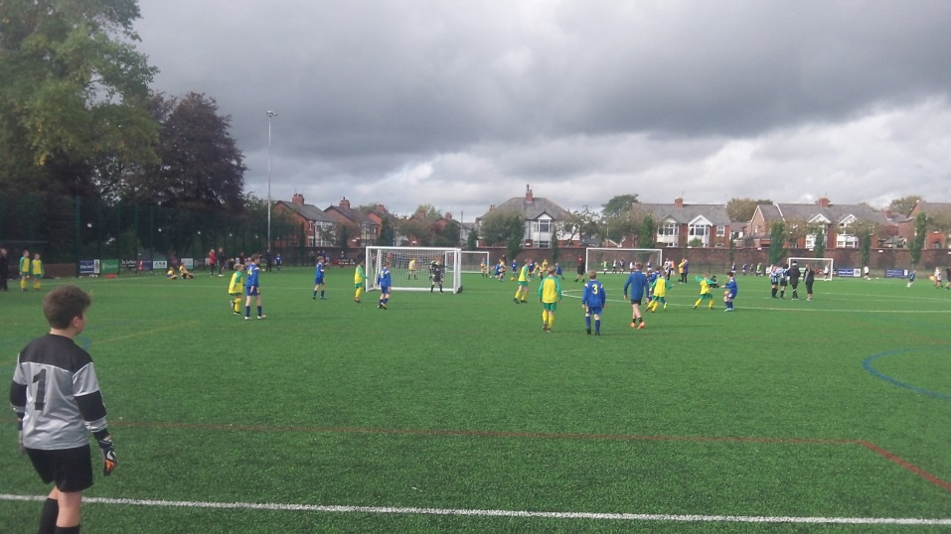

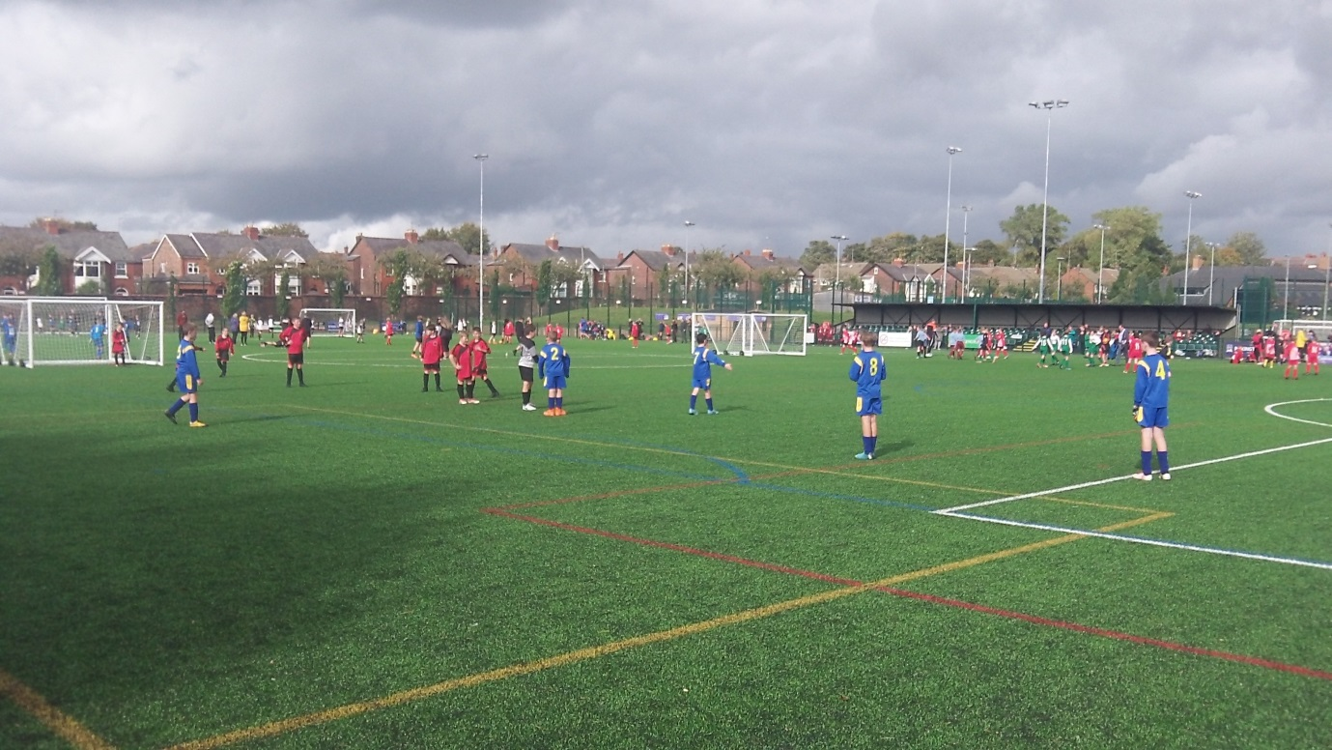

Well done James, Matthew, Ewan, Jack, Harrison, Lewis, Connor and Carl for such a fantastic achievement!

