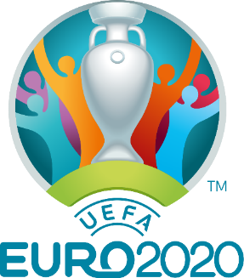
Rivi Euro Football Tournament
June 2021
Inspired by Euro 2020, we decided to hold our own whole school Euro Football Tournament this week. The children competed in their houses, where they played 3 matches against other teams. It was a fantastic enjoyable afternoon of football, where the children demonstrated their superb teamwork, determination and sportsmanship skills.
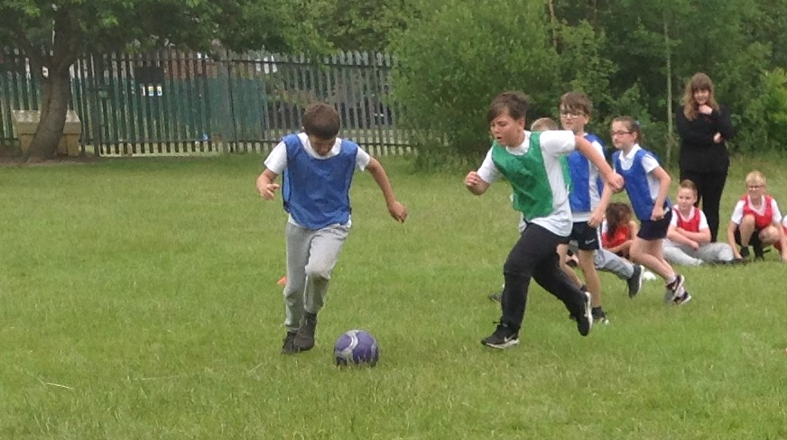
We had penalties for our own England and Sweden teams to decide who went into the Rivi Euro final.

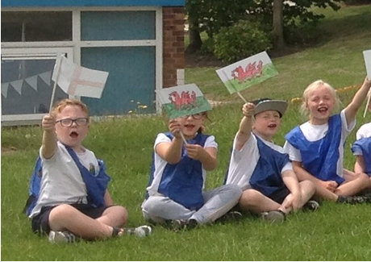
Everyone had great fun competing in the Rivi Euro Football Tournament and now we all hope England have as much fun and do well in Euro 2020.
