Orienteering Festival
July 2021
During our orienteering festival, all classes have taken part in orienteering activities as part of their Outdoor Adventurous Activities. Orienteering is an exciting outdoor adventure sport which involves walking or running whilst navigating around a course using a detailed map and sometimes a compass. The aim is to navigate in sequence between a set of control points and decide the best route to complete the course in the quickest time. The children all had a great time and worked well in their teams.
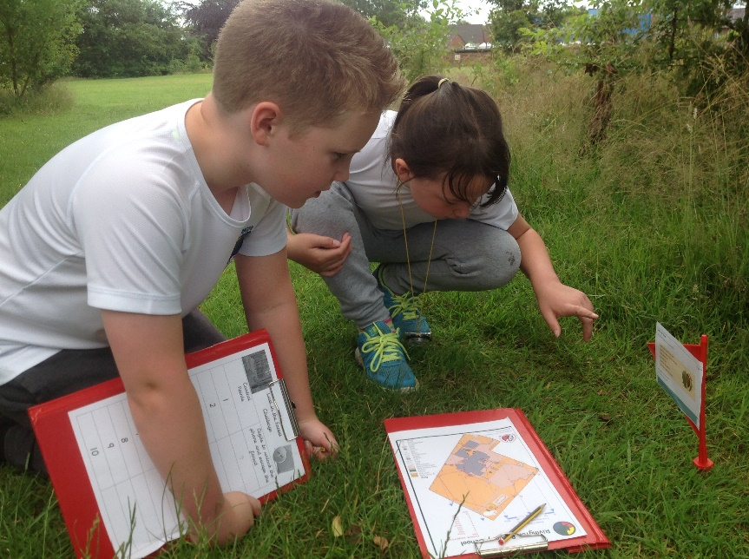

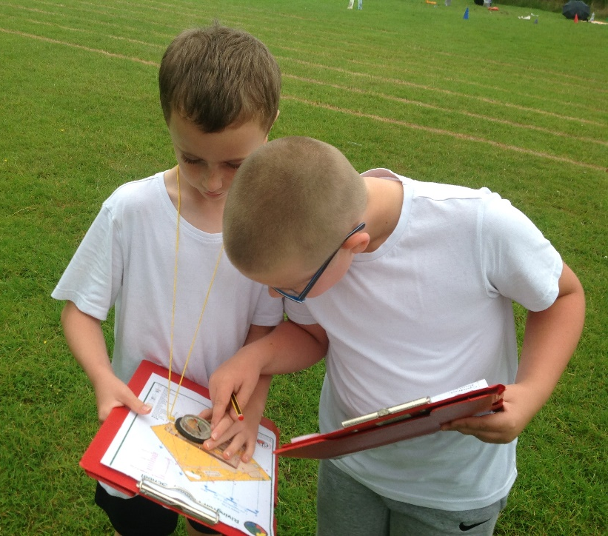

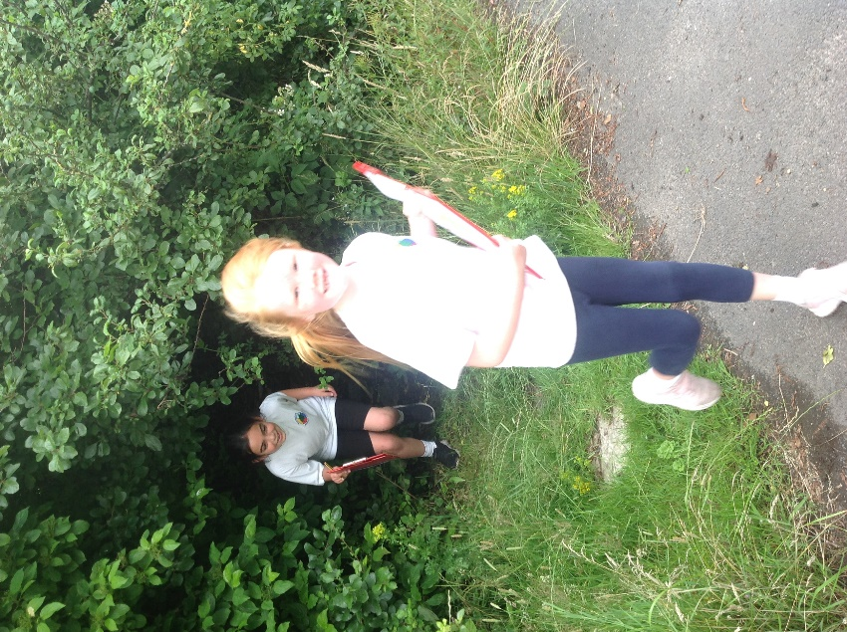

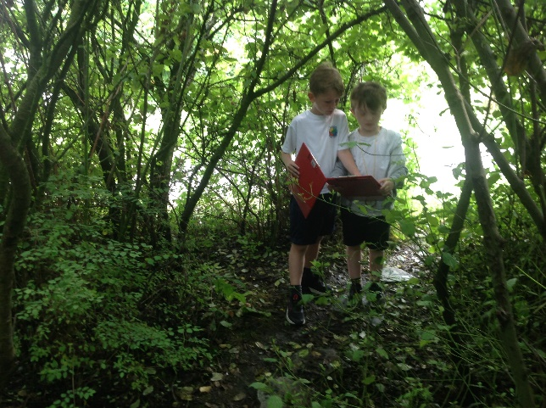
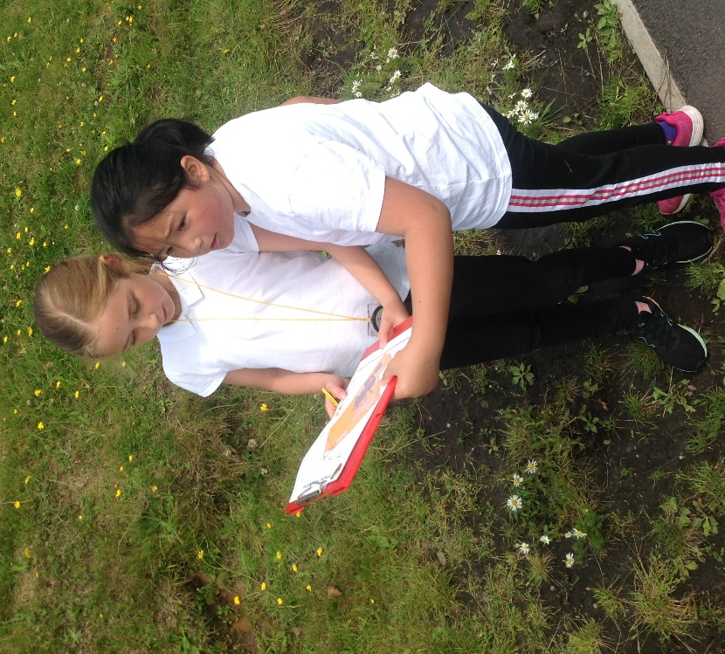
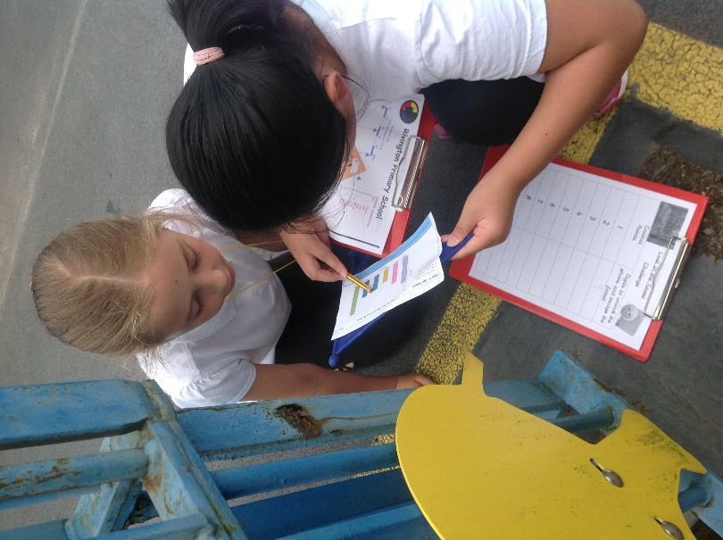
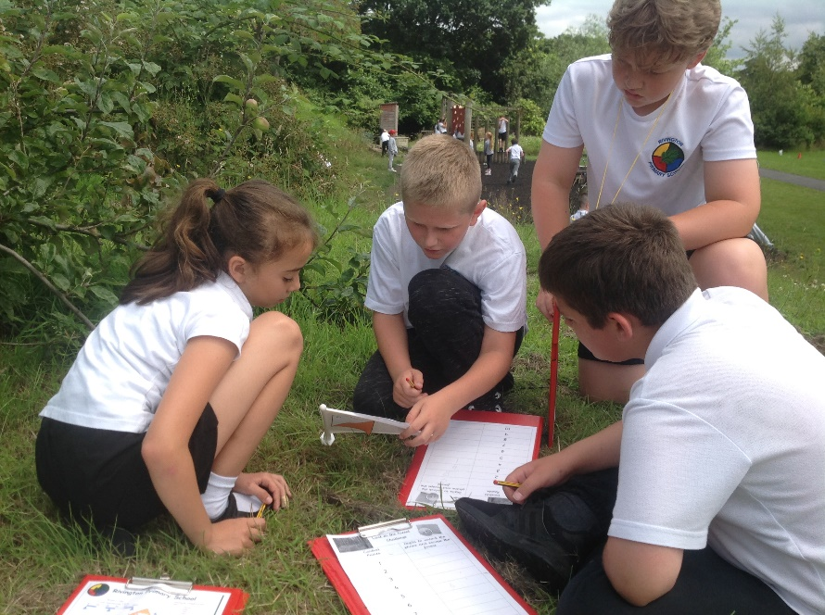

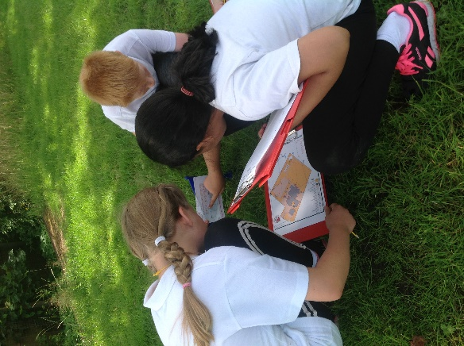
The children carried out a number of exciting team building and map reading activities before finishing the afternoon with a full orienteering course.
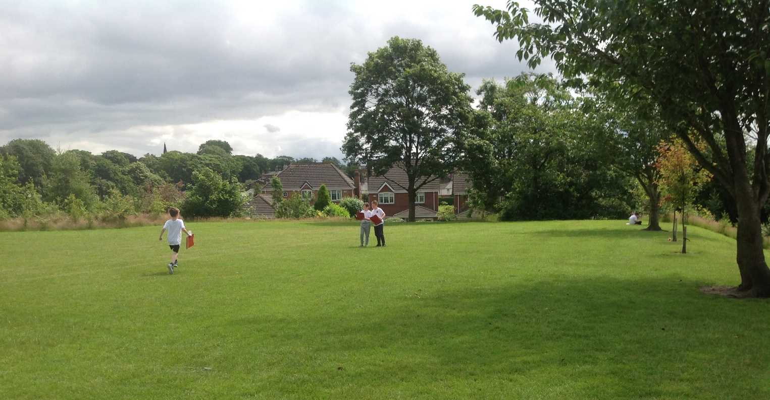
In Year 4, the children had to navigate around the course solving a range of mathematical problems at each control point.

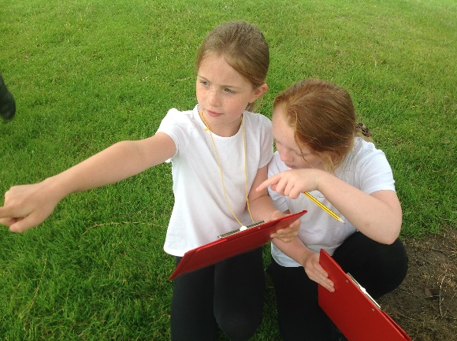
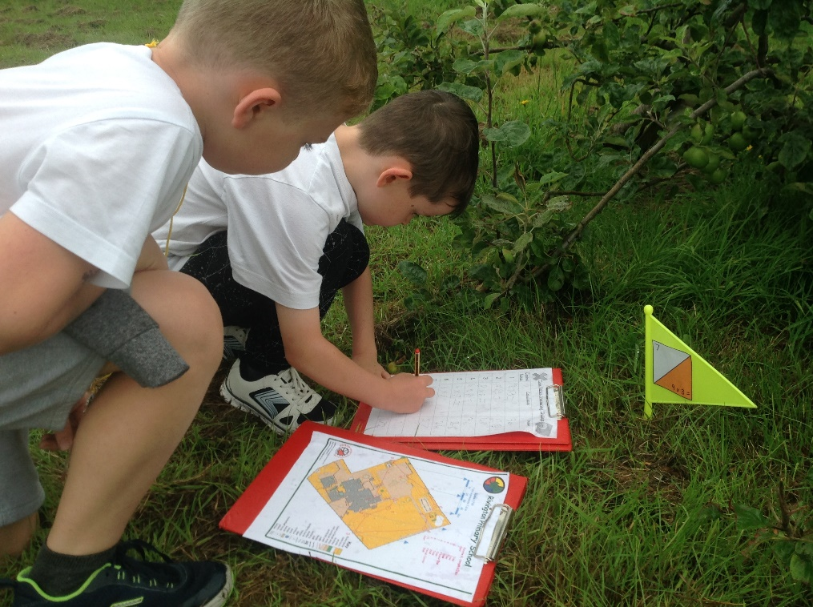
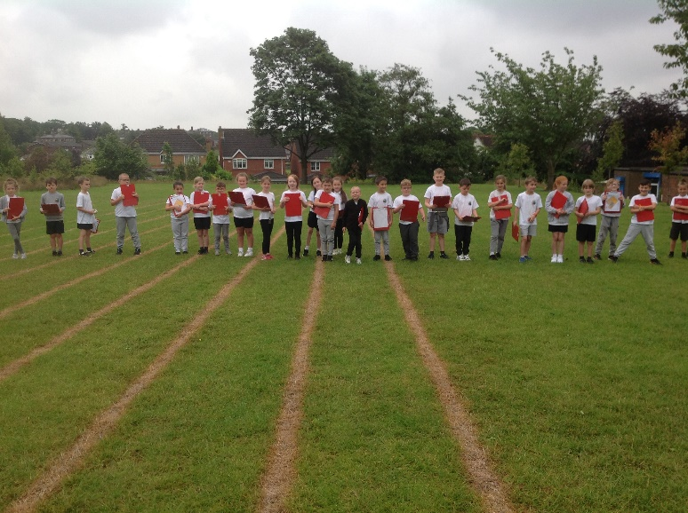
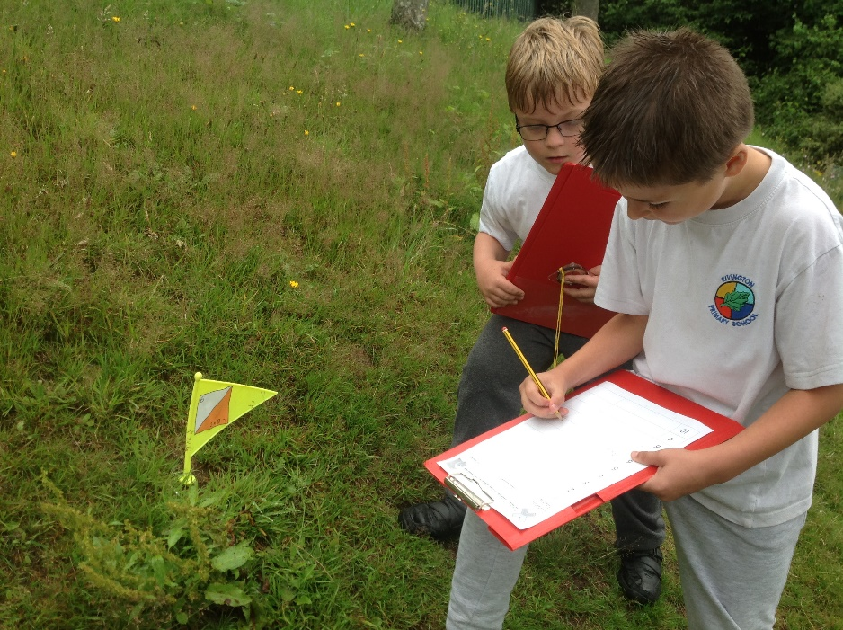

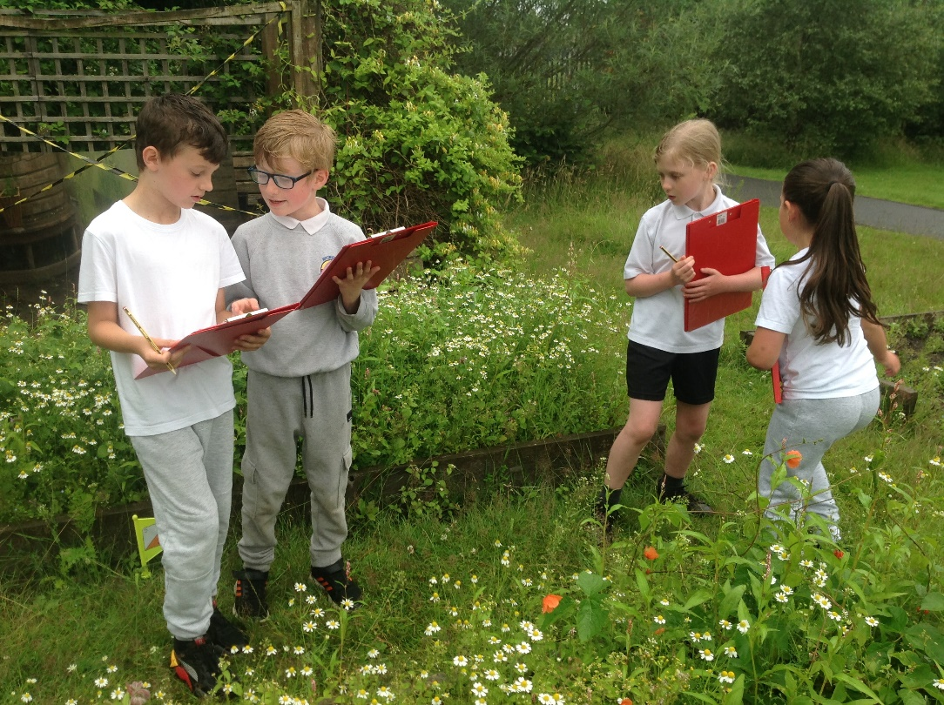
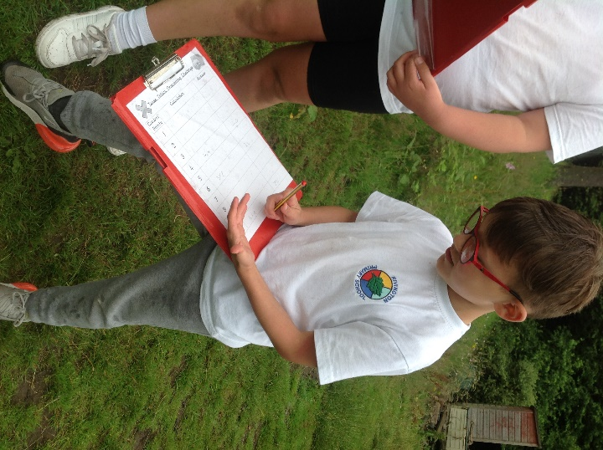

Each class was split into teams to compete and each team was appointed a team leader.
Year 3 timings for their event were as follows:

Team Noah - 20mins 22secs
Team Toby - 21mins 28secs
Team Finn - 23mins 27secs
Team Emily - 24mins 6secs
Team Daphne – 25 mins 27 secs
Team Harry – 25 mins 34 secs
Team Ava - 26mins 28secs
Team Anya - 27mins 19secs
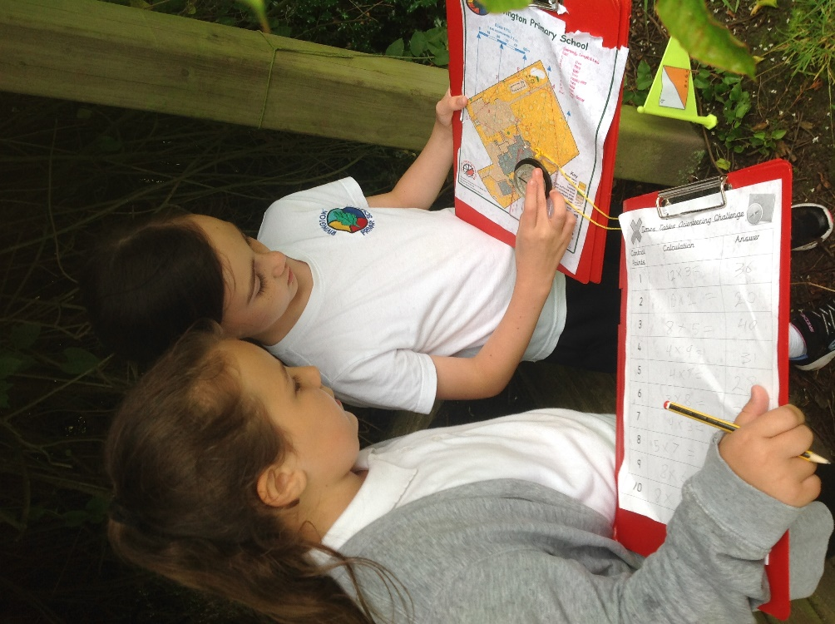
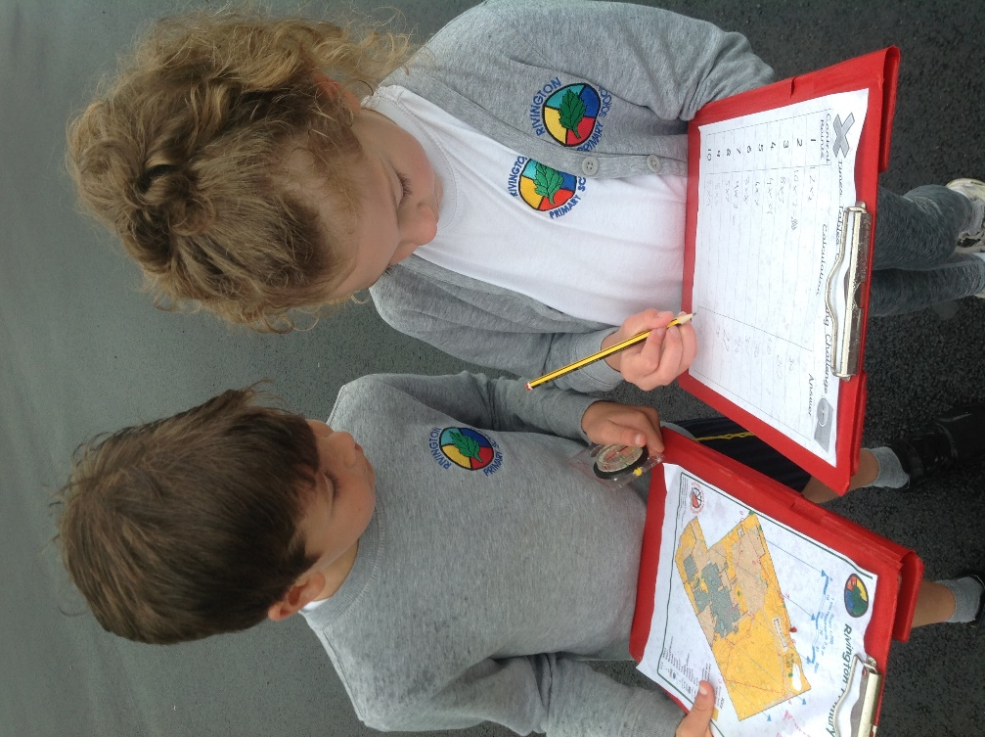
Team Victor – 27 mins 32 secs

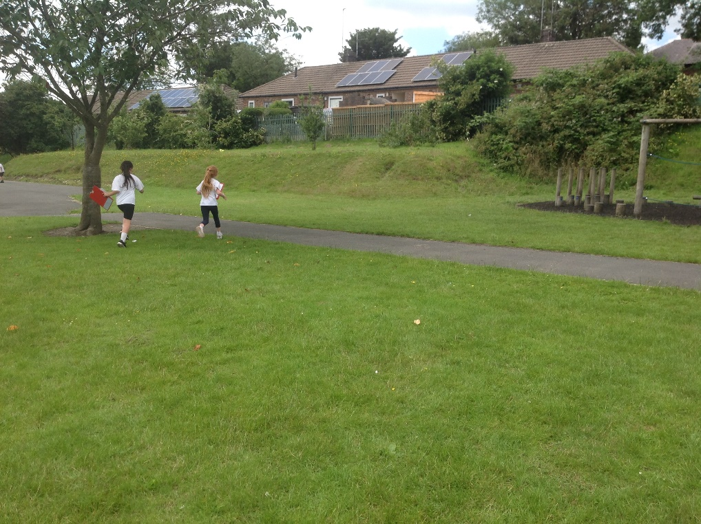

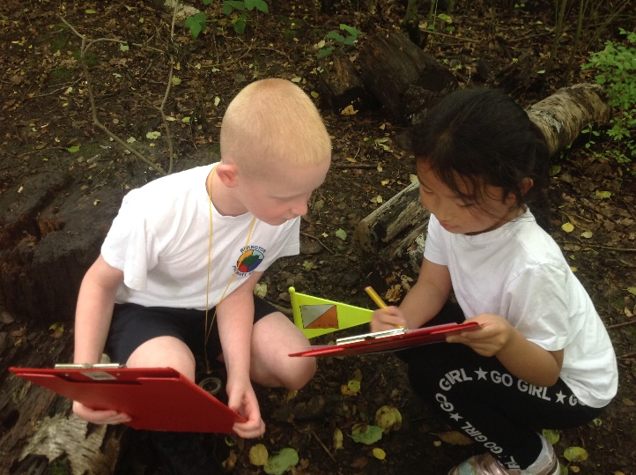

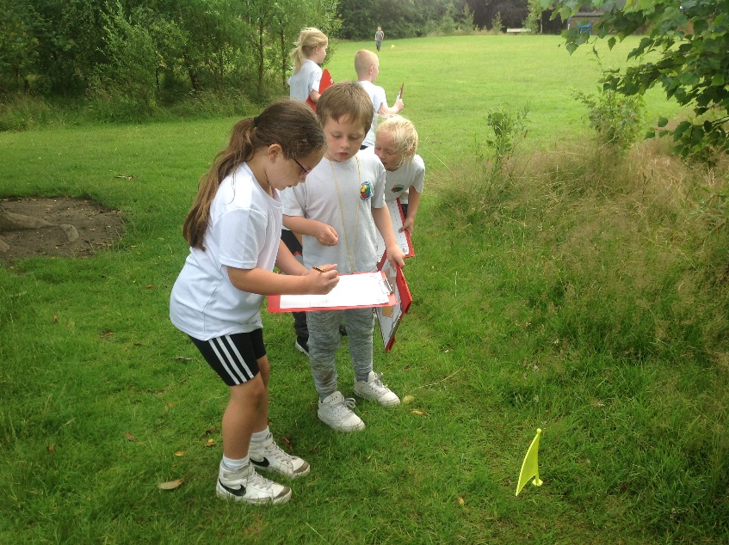
In Year 1 and Year 2, the children took part in a range of activities giving them a taster of the sport of orienteering. The children took part in a number of orienteering-based games and activities from learning map reading skills, orienteering symbols and navigating around cones.

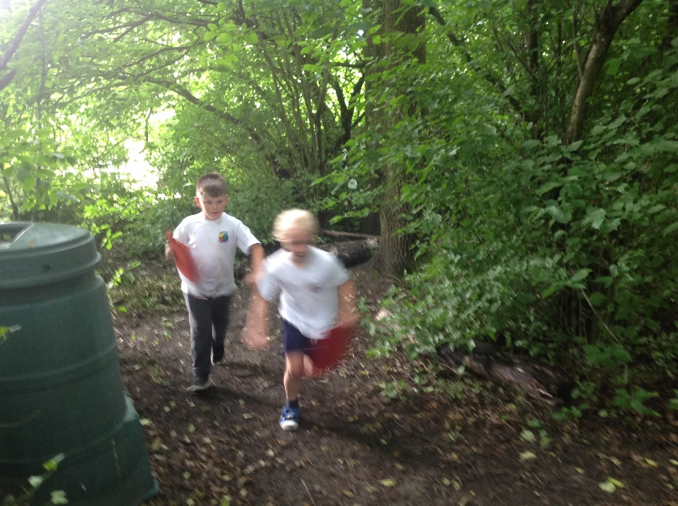
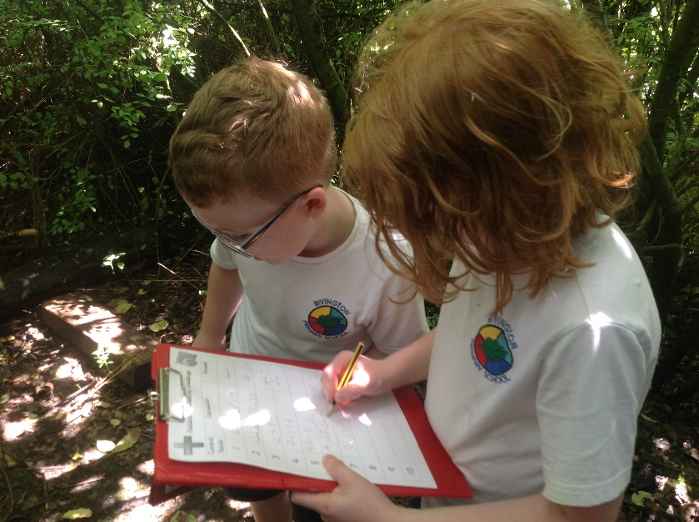

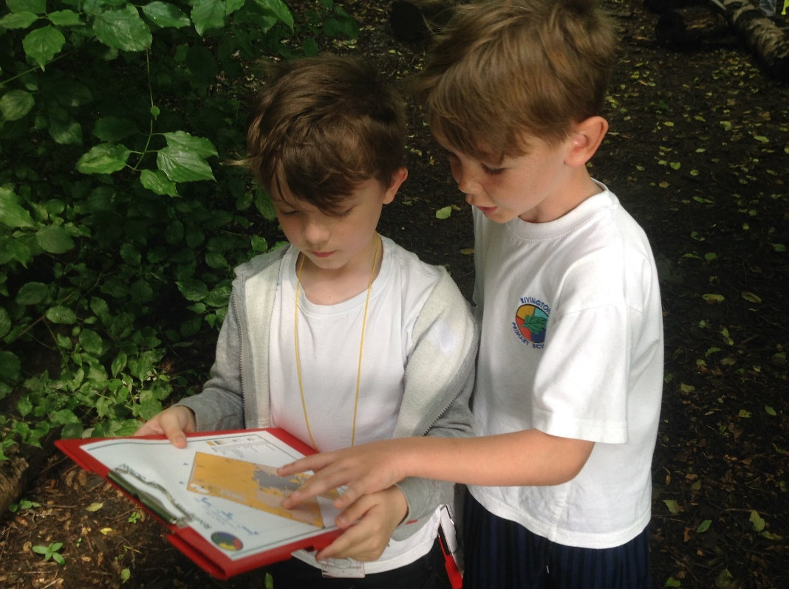
The children in Year 2 had to navigate around a course solving a range of addition and subtraction calculations at each control point.

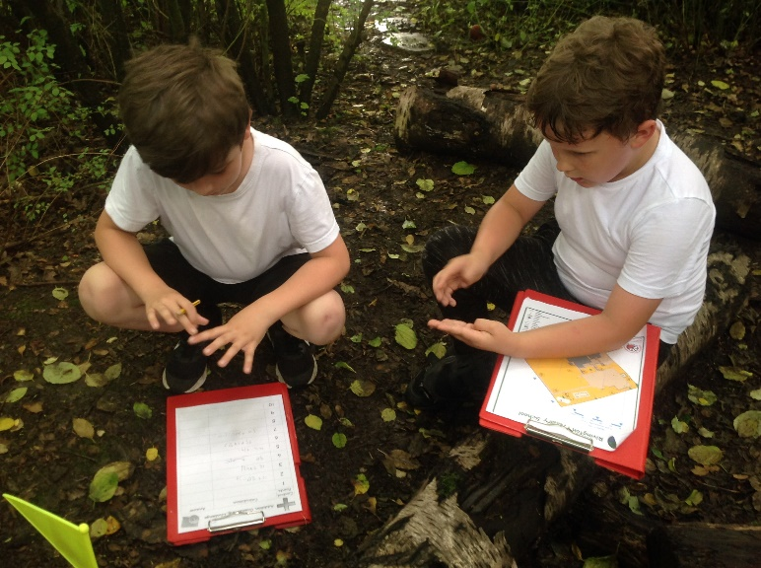

The children in Year 1 had to use their phonic knowledge to read and identify the alien and real words at each control point.

