EYFS
- Make imaginative and complex ‘small worlds’ with blocks and construction kits, such as a city with different buildings and a park.
- Explore different materials freely, in order to develop their ideas about how to use them and what to make.
- Develop their own ideas and then decide which materials to use to express them.
- Join different materials and explore different textures.
- Uses various construction materials, e.g. joining pieces, stacking vertically and horizontally, balancing, making enclosures and creating spaces.
- Uses tools for a purpose.
- Return to and build on their previous learning, refining ideas and developing their ability to represent them.
- Safely use and explore a variety of materials, tools and techniques, experimenting with colour, design, texture, form and function.
- Share their creations, explaining the process they have used.
- Uses their increasing knowledge and understanding of tools and materials to explore their interests and enquiries and develop their thinking.

Autumn | Spring | Summer
Unit Title: Festivals – Modelling | Unit Title: Who likes the cold?  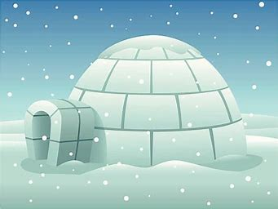 | Unit Title: Once upon a time…  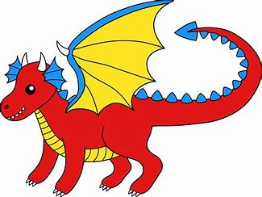
Prior skills and Knowledge:  - Explore different materials  - Join materials with tape and glue | Prior skills and Knowledge:  - Explore different materials  - Creating enclosures with construction toys.  - Den making  - Exploring large loose parts / construction | Prior skills and Knowledge:  - Exploring malleable materials  - Joining materials in different ways
Skills:  - Can I use scissors to cut materials using one hand?  - Can I use tools safely with adult support?  - Can I use a range of joining techniques, choosing the most appropriate?  - Can I explain how I made my model? | Skills:  - Can I talk about my ideas and draw my design?  - Can I describe different textures?  - Can I explain how I made the product? | Skills:  - Can I talk about my ideas and draw my design?  - Can I use a rolling pin and cutter effectively?  - Can I choose the most appropriate materials?  - Can I talk about how I refined my design?
Knowledge:  - Know how use pritt stick, PVA and masking tape correctly.  - Know to hold scissors and use them safely to cut paper and card.  - Know how to use tools safely. | Knowledge:  - Know what a shelter is.  - Know how to join materials effectively. | Knowledge:  - Know how ingredients are mixed and notice how they change.  - Know how to use tools safely.  - Know that I can change my ideas to improve my design.
Key moments in file:  - Photos of the processes. (i.e. children’s use of scissors and glue)  - Photos of the final outcome - model | Key moments for file:  - Designs for shelters/homes.  - Photos of the process, children making shelters.  - Photos of final pieces | Key moments in file:  - Video of planning/designing discussion.  - Photos of the process, children making biscuits / dragon scarers or traps.  - Image of the final outcome.
Final outcome:  Firework rocket decorations / Fire engine model | Final outcome:  Shelters or homes for arctic animals/Collaborative collage. | Final artwork:  Gingerbread men/cookies for a traditional tale character. Scarer/trap for a villain.
Key Vocabulary:  cut, snip, tape, glue, join, shape, tools, scissors, carve. | Key Vocabulary:  Shelter, wall, roof, join, tape, long, short, tall, taller, wide, narrow.  Smooth, rough, soft, bumpy, shiny, dull | Key Vocabulary:  Trap, camouflage, tall, short, narrow, wide.  Ingredients, mix, stir, bake, soft, hard, crunchy.
Curriculum links:  Art  Science | Curriculum links:  Geography  Science | Curriculum links:  English  Science

