EYFS
• Remember and sing entire songs.
• Sing the pitch of a tone sung by another person (‘pitch match’).
• Sing the melodic shape (moving melody, such as up and down, down and up) of familiar songs.
• Create their own songs, or improvise a song around one they know.
• Play instruments with increasing control to express their feelings and ideas.
• Uses movement and sounds to express experiences, expertise, ideas and feelings.
• Experiments and creates movement in response to music, stories and ideas.
•Listen attentively, move to and talk about music, expressing their feelings and responses.
• Watch and talk about dance and performance art, expressing their feelings and responses.
• Sing in a group or on their own, increasingly matching the pitch and following the melody.
• Uses combinations of art forms, e.g. moving and singing, making and dramatic play, drawing and talking, constructing and mapping.
• Responds imaginatively to art works and objects, e.g. this music sounds likes dinosaurs.
• Sing a range of well-known nursery rhymes and songs.
• Perform songs, rhymes, poems and stories with others, and (when appropriate) try to move in time with music.

Autumn 1 | Autumn 2 | Spring 1 | Spring 2 | Summer 1 | Summer 2
Unit Title:  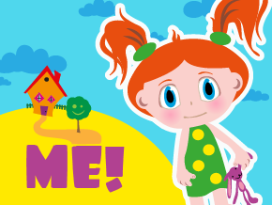 | Unit Title:  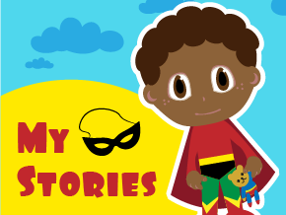 | Unit Title:  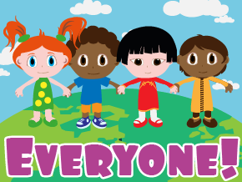 | Unit Title:  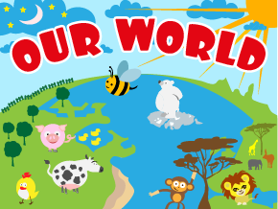 | Unit Title:  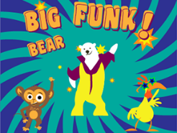 | Unit Title:  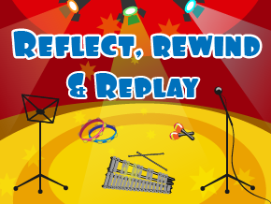
Prior skills and Knowledge:  Explore instruments, sing nursery rhymes and songs | Prior skills and Knowledge:  Explore high and low sounds, finding the pulse. | Prior skills and Knowledge:  Make patterns using one note.  Exploring pitch | Prior skills and Knowledge:  Creating melodic patterns  Copy clapping the rhythm. | Prior skills and Knowledge:  Creating melodic patterns  Copy clapping the rhythm. | Prior skills and Knowledge:  Creating melodic patterns using 3 notes.  Copy clapping the rhythm.
Skills:  - Can I clap the rhythm of my name?  - Can I find the pulse? | Skills:  - Can I copy clap the rhythm of short phrases  - Can I find the pulse? | Skills:  - Can I invent a way to find the pulse?  - Can I copy clap phrases from songs? | Skills:  - Can I invent a way to find the pulse and show others my idea?  - Can I copy clap phrases from songs? | Skills:  - Can I keep the beat of a song?  - Can I copy clap 3-4 word phrases from songs? | Skills:  - Can I appraise a piece of classical music?
Knowledge:  - Know that the pulse is a steady beat. | Knowledge:  - Know that pitch means how high or low a sound is. | Knowledge:  - Know how to make a melodic pattern. | Knowledge:  - Know how to make a melodic pattern. | Knowledge:  - Know how to make a pattern using 3 notes. | Knowledge:  - Know that rhythm is a combination of long and short sounds.
Key moments:  Videos of the games | Key moments:  Videos of the games | Key moments:  Videos of the games | Key moments:  Videos of the games | Key moments:  Videos of the games | Key moments:  Videos of the children’s appraisals.
Final outcome:  Video of singing performance. | Final outcome:  Video of patterns created | Final outcome:  Video of melodic patterns created | Final outcome:  Video of melodic patterns created | Final outcome:  Video performance | Final outcome:  Video performance
Key Vocabulary:  Rhythm, pulse, high, low | Key Vocabulary:  Rhythm, pulse, high, low, pitch | Key Vocabulary:  Rhythm, pulse, high, low, pitch | Key Vocabulary:  Rhythm, pulse, high, low, pitch | Key Vocabulary:  Rhythm, pulse, high, low, pitch, funk music | Key Vocabulary:  Rhythm, pulse, high, low, pitch
Curriculum links:  English  PSHE | Curriculum links:  RE | Curriculum links:  Geography  PSED | Curriculum links:  Geography  Science | Curriculum links: | Curriculum links:  History

