EYFS
- Explore, use and refine a variety of artistic effects to express their ideas and feelings.
- Return to and build on their previous learning, refining ideas and developing their ability to represent them.
- Create collaboratively, sharing ideas, resources and skills.
- Create closed shapes with continuous lines and begin to use these shapes to represent objects.
- Draw with increasing complexity and detail, such as representing a face with a circle and including details.
- Use drawing to represent ideas like movement or loud noises.
- Show different emotions in their drawings and paintings, like happiness, sadness, fear, etc.
- Explore colour and colour mixing. Show different emotions in their drawings – happiness, sadness, fear, etc.
Autumn | Spring | Summer
Unit Title: Drawing Nature  Students will explore the nature around them, visiting the school grounds and the woods for inspiration. | Unit Title: Sculpture and photography - clay | Unit Title: Dazzle Ships  Students will explore pattern and colour to create a dazzle ship.
Artist:  Richard Shilling  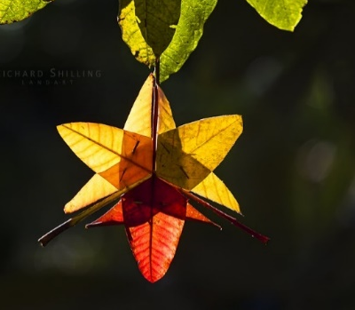  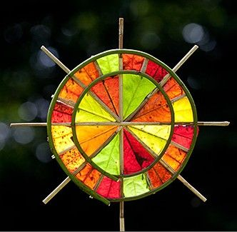 | Artist:  Barbara Hepworth  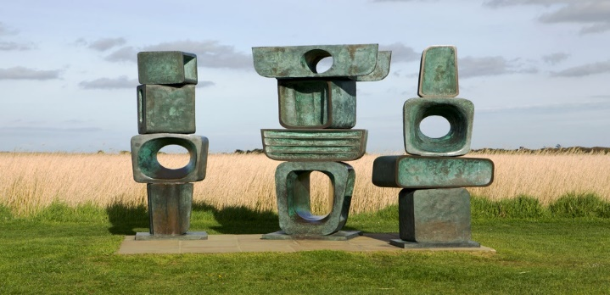 | Artist:  Peter Blake – Mersey Ferry  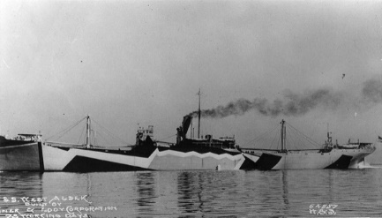  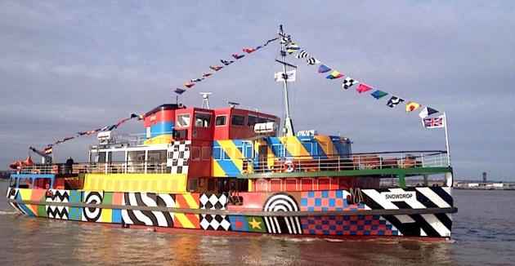
Skills:  - Can I hold a pencil to make different marks (tripod grip, fist, handlebar)?  - Can I make a variety of marks with a pencil?  - Can I explore the different marks made by different drawing materials?  - Can I create enclosed shapes to represent different subjects? | Skills:  - Can I mould and shape clay using my hands?  - Can I mould and shape clay using tools?  - Can I observe the view through a frame?  - Can I photograph different views? | Skills:  - Can I create a simple pattern using shapes?  - Can I make a representation of a boat from recycled materials?  - Can I correctly hold a pair of scissors?  - Can I cut paper with scissors?  - Can I add a simple pattern to an object or design?
Knowledge:  - To identify different natural objects  - To understand the marks they can make with a pencil by holding it in different ways. | Knowledge:  - To know how clay can be moulded with hands and tools.  - To know how to frame a view. | Knowledge:  - Dazzle camouflage, also known as razzle dazzle (in the U.S.) or dazzle painting, was a family of ship camouflage used in World War I, and to a lesser extent in World War II and afterwards.  - To be able to recognise a visual pattern.  - To understand how to create a simple pattern.
Key moments in file:  - Experimental marks made using a pencil and different grips  - Experimental marks made with different drawing materials.  - Leaves, twigs and responses to them using a pencil and other drawing materials such as charcoal, graphite sticks, different grades of pencil. | Key moments for file:  - Photos of experimental marks and shapes made in clay.  - Photos of different views taken by the students.  - Photos of the final sculptures hanging up and framing a view. | Key moments in file:  - Experimental patterns using paper, pencils or other materials.  - Images of dazzle ships and responses to them.  - Image of the final construction.
Final artwork:  Collaborative artwork/drawing using natural objects. | Final artwork:  Hanging clay sculptures that include a hole to frame a view. | Final artwork:  Collaborative dazzle ship sculpture.
Key Vocabulary:  Leaves, branches, pencil, charcoal, mark, straight, wavy, twig, texture, nature, drawing, artist. | Key Vocabulary:  Clay, mould, shape, tools, squeeze, press. | Key Vocabulary:  Pattern, boat, ship, camouflage, make, decorate, draw, stick, cut, scissors.
Curriculum links:  Geography  Science | Curriculum links:  Photography | Curriculum links:  DT  History

