The ‘Rivington Way’ Nursery – Year 6
Behaviour and Attitudes Curriculum

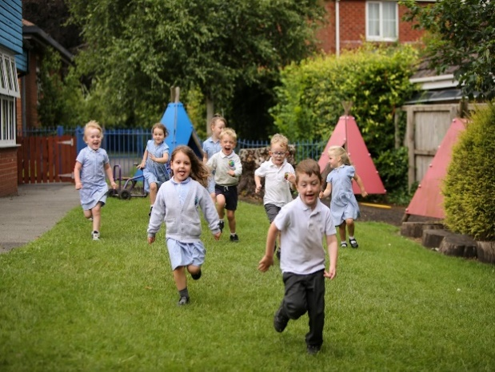
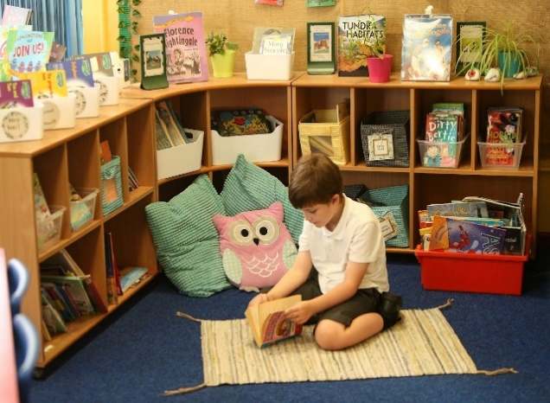

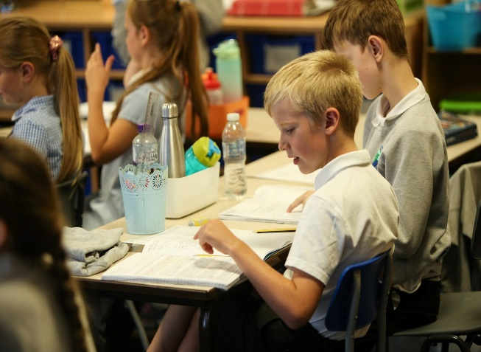

 | Autumn 1 | Autumn 2 | Spring 1 | Spring 2 | Summer 1 | Summer 2
All Year Groups  Nursery to Year 6 | Explicit teaching of the full content of the ‘Rivington Way’ | Ongoing revision of content with a specific focus on Manners | Ongoing revision of content with a specific focus on  Classroom Routines | Ongoing revision of content with a specific focus on Break / Lunch time | Ongoing revision of content with a specific focus on friendships | Ongoing revision of content with a specific focus on behaviour outside of school
Overview of Content

Introduction

At Rivington, we develop our children’s character through the explicit teaching of the ‘Rivington Way’, our behaviour and attitudes curriculum. To build character, we define the behaviours, habits, social norms and values that we expect our pupils to demonstrate. We want to support our pupils to grow into adults who are polite, respectful, grateful and who put others before themselves. We believe that as pupils practise these behaviours over time, they become embedded habits that enable them to contribute positively to our school community and beyond every day.

Teaching the Rivington Way

The curriculum is taught explicitly during the first week of Autumn term alongside the traditional National Curriculum subjects. Children should learn the content of the curriculum so that they can recall the information and act upon it. To ensure this culture is embedded, we decided upon a process of specifically teaching these positive behaviours by first identifying the routines we wanted to see, communicating our expectations in detail to all stakeholders, ensuring routines are practised until everyone can do them and then continuing to reinforce, maintain and patrol them constantly.

At the start of each term, the ‘Rivington Way’ is revisited and taught with pupils and continues to be reinforced throughout the year. All school staff demonstrate these behaviours consistently and ensure pupils have many opportunities to practise these (particularly in the first few days of each term). For example, lining up in register order should be taught in the classroom but must be reinforced in different locations and times throughout the school day e.g., at lunchtime or playtime. It is expected that all pupils will know this content.

It is essential that all staff know the details of this curriculum, teach it explicitly to pupils through the reinforcement of our values and continuously maintain the high standards we set. By doing so, we support each other to create a culture where pupils feel safe, can learn in an optimised environment and where teachers are free to teach unimpeded.

Adaptations

While this curriculum is intended for all pupils, it will be applied differently in different year groups depending on pupils’ ages and may be applied differently depending on individual pupils’ SEND needs. For example, pupils who have autistic spectrum conditions may find it very uncomfortable to maintain eye-contact with adults. Sensitivity must be applied at all times when teaching this curriculum.

The ‘Rivington Way’ Curriculum Content
(Content to be covered in depth in Autumn Term 1 and revisited throughout the year based around our school values)

Our School Values
Know that there are four school values. These are to:
- Respect
- Keep Peace
- Protect
- Give Thanks

Know the following examples of these values:
Say please and thank you
Hold doors open for adults and other children
Talk kindly to other pupils
Say good morning/ afternoon to adults
Remembering to bring equipment to school (PE days, reading bags, homework etc.)
Tidying up your own workspace and the classroom
Accepting responsibility if you make a mistake and saying sorry
Sitting still
Listening carefully to the teacher
Giving the teacher 100% of your attention
Working hard on tasks given
Being in the right place at the right time
Don’t run anywhere in school
Do not leave the classroom unless you have permission to do so
Children know the expectations of the ‘Rivington Way’, are rewarded for demonstrating these behaviours and that there will be consequences/sanctions if they don’t follow them.

Moving around School

Know that we walk around school using ‘Rivington Walking’.
Know that ‘Rivington Walking’ means –

- Facing forwards
- walking at a steady pace
- in a straight line
- with hands by your side
- without talking

Know that when we move around school we walk on the left of the corridor or stairs
Know that we use ‘Rivington Walking’ to keep everyone safe in school and to make sure the learning of other children is not disrupted as people move around school.

Classroom routines

Know that we use ‘Rivington Listening’ in class.
Know that this means –

- Facing forwards
- Always sit up straight
- Two feet on the floor
- Never interrupt
- Track the speaker

Know that we all use ‘Rivington Listening’ to ensure everybody is able to learn without distractions.
Know the order that you always line up in register order.
Know who you stand in front of and who is behind you.
Know that you should line up without leaning against the walls while moving around school.
Know the routine for entering the classroom and getting ready to work.
Know where you sit in class during lessons (including ‘carpet places’)
Know that you remain in your seat during lesson time.
Know the routine for handing out and collecting exercise books in the classroom.
Know where to hang up your coat and look after your belongings.
Know that you should only go to the toilet at playtime and lunchtime or when absolutely necessary.
Know that you need to get equipment out ready for the lesson and to look after it.
Know that any deliberate damage to school equipment will incur a consequence.
Know that it is important to speak clearly in class when sharing answers so that everyone can hear.
Know that when you want help from an adult you raise your hand and wait quietly unless the teacher has indicated otherwise.

Completing work in books

Know how to set out work in books according to the ‘Rivington Way’ book contract (see separate document).
Know that each piece of work has a LO sticker.
Know how to underline using a ruler.
Know how to correct mistakes by drawing a straight line through your work.

Manners

Know that we use our manners at Rivington to make sure we are always polite to each other.
Pupils use an adult’s full name when talking to them.
Pupils know that they should say ‘thank you’ when they receive something, or someone does something nice for them.
Pupils know that they should say ‘excuse me’ if someone is in their way.
Pupils know that they should always say ‘please’ when they are asking for something.
Pupils know that they should be positive and upbeat when talking to adults and each other
Know that you should let anybody waiting through a doorway before walking through yourself.
Know that you should say ‘Good morning/afternoon’ to adults if spoken to.
Know that it is polite to ask questions such as “How are you today?”, “Have you had a good morning?”
Know that it is polite to give eye contact to the person you are talking to.
Know that it is important to show gratitude to others by thanking people for what they have done for you.
Know that it is important to have good manners so that people act politely back to you

Playtime/Lunchtime Behaviour

Know that you must walk from your classroom to the playground using ‘Rivington Walking’.
Know that you must play safely without hurting anyone.
Know that we do not ‘play fight’ because we may hurt someone by accident.
Know that you must be kind, by including people in your games and sharing equipment.
Know that someone who is kind behaves in a gentle, caring, and helpful way towards other people.
Know that, when the first whistle blows you stand still/2nd whistle walk to your line quickly and quietly.
Know where you sit in the dinner hall during lunchtime.
Know how to queue patiently and respectfully.
Know that you should use a quiet voice in the dinner hall.
Know that you should always try to use a knife and fork correctly (this will be explicitly taught in EYFS and KS1)
Know that you should finish what you are eating before leaving your seat.
Know that you must clean up after yourself and the area around where you have been sat.
Know that if something is spilt or dropped on the floor it is your responsibility to either pick it up or report to an adult
Know how to use good manners during lunchtime, particularly when receiving food from the school kitchen and talking to midday supervisors.
Know that ‘good manners’ means saying ‘please’ when you ask for something and ‘thank you’ when you receive it.

Preventing Bullying

Know that bullying is:

- Hurting someone else on purpose
- Repetitive – it happens again and again
- Can be physical, verbal, and emotional

Know that bullying can be indirect. This means:

- Leaving people out of groups or games
- Talking about someone behind their back
- Standing by and watching someone get bullied without letting an adult know

Know that if this happens online, it is called cyberbullying.
Know that if you think you are being bullied you should tell an adult.
Know that if you think someone is being bullied you should tell an adult.
Know that bullying is unacceptable and that it will be dealt with seriously by all adults at Rivington.

School Uniform

Know that school uniform consists of –
Dark trousers, black or grey skirt, white polo shirt, school sweatshirt and black shoes. Dark shorts can be worn in the warmer weather as can blue check dresses.
Know that all shirts must be tucked in.
Know that long hair must be tied back.
Jewellery - Know that for health and safety reasons, we do not allow pupils to wear jewellery in school except for earring studs in pierced ears, small objects of religious significance and a watch.
PE - Know that for PE, pupils must wear black shorts or black tracksuit bottoms, white T-shirt, trainers for outside.
Know that indoor PE is done in black pumps.

End of the day routine

Know that they must stand with the teacher at the meeting point.
Know that they must not go home until the teacher has checked that the correct adult is picking them up.
Know that these procedures are put in place to keep all children safe at home time.

Attendance and Punctuality

Know that you must attend school every day.
Know that you must arrive at school on time every day.
Know that attending school on time every day is important so that you don’t miss important learning.

Behaviour outside school

Know that when you are wearing your school uniform you are representing the school community and must always behave responsibly and respectfully.
Know that you should be considerate of other people arriving and leaving school.
Know that being considerate means thinking about other people’s needs, wishes and feelings.
Know that examples of being considerate on the way home include walking not running, giving people plenty of space, using a quiet voice (not shouting).

Summary

Know that the ‘Rivington Way’ must always be followed.
Know that all pupils follow the ‘Rivington Way’ to become better learners and to build positive habits which will help everyone to be successful throughout life.

