Cricket Competition
June 2021

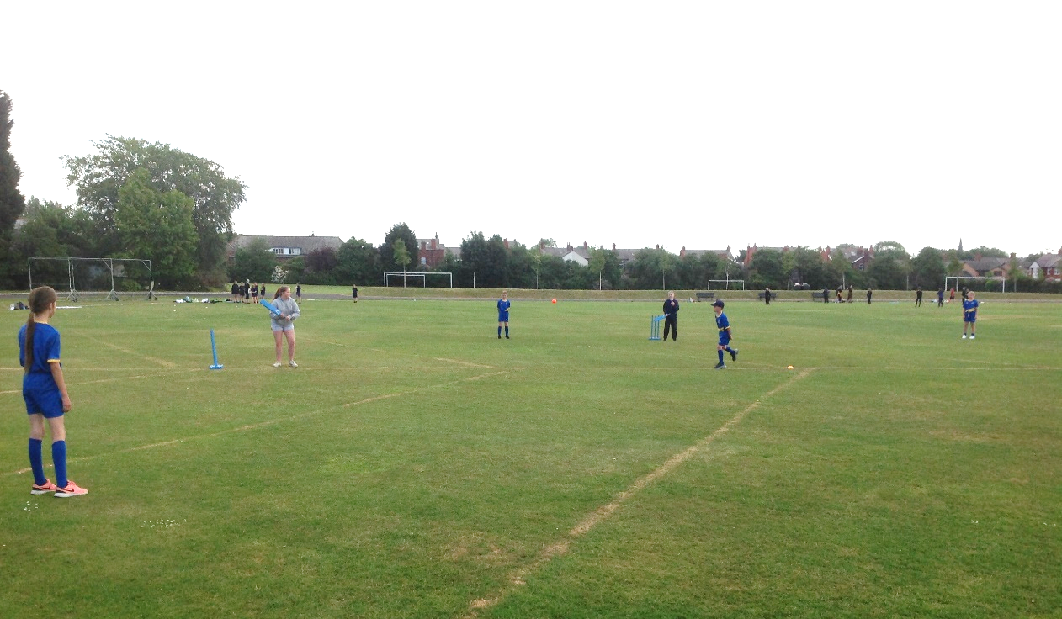
Well done to our Year 6 Cricket team who competed in the St Helens Cricket Competition at Ruskin Drive Sports Centre on Tuesday. The team played really well and competed against other schools across St Helens throughout the day. A combination of determination, desire and skill saw the team narrowly finish second in the tournament, only losing one game to the winning team.
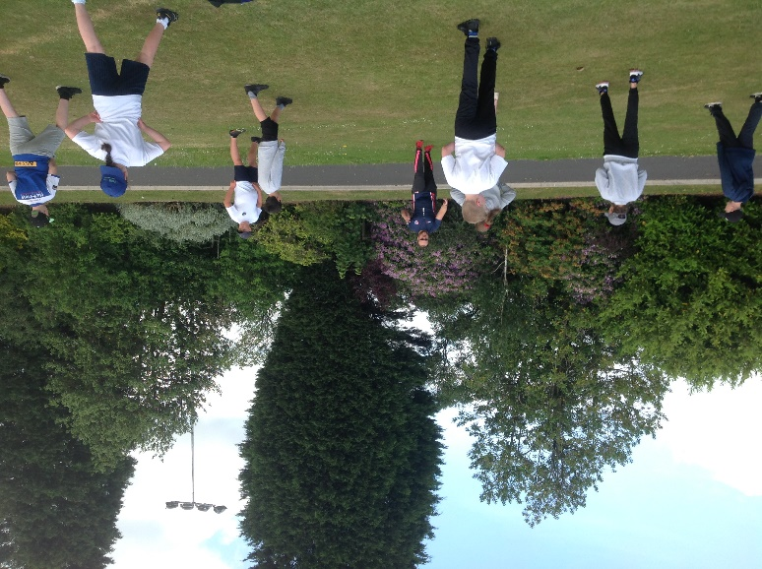
Warm up with Mr Glynn before the
competition begins.

Rivington 20 Birchley St Marys 10

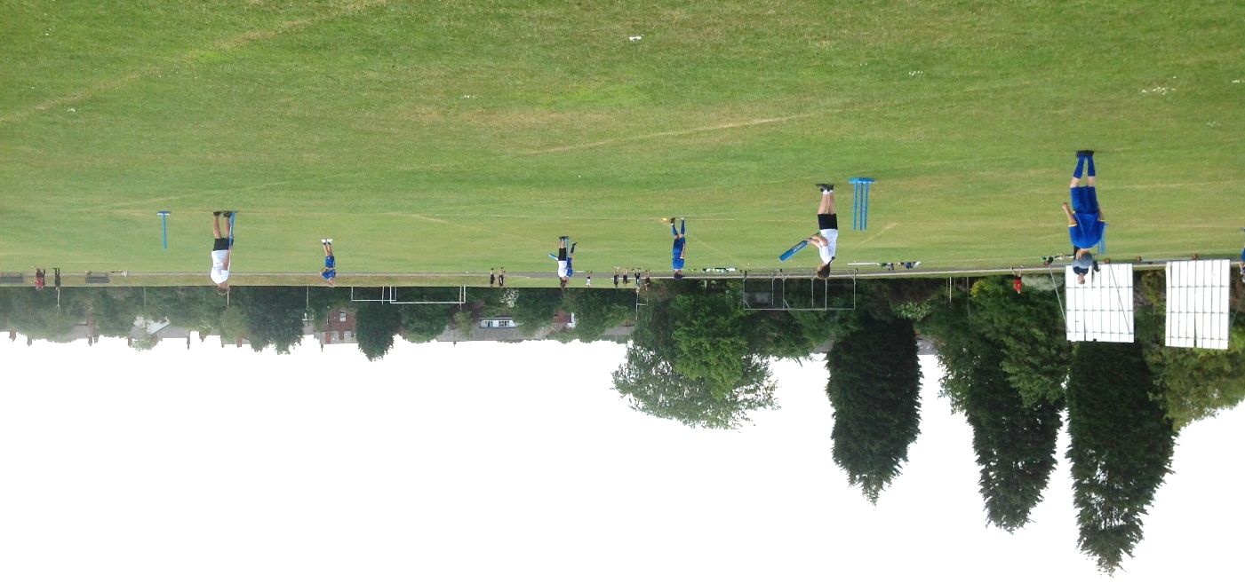
Rivington 24 Garswood 21

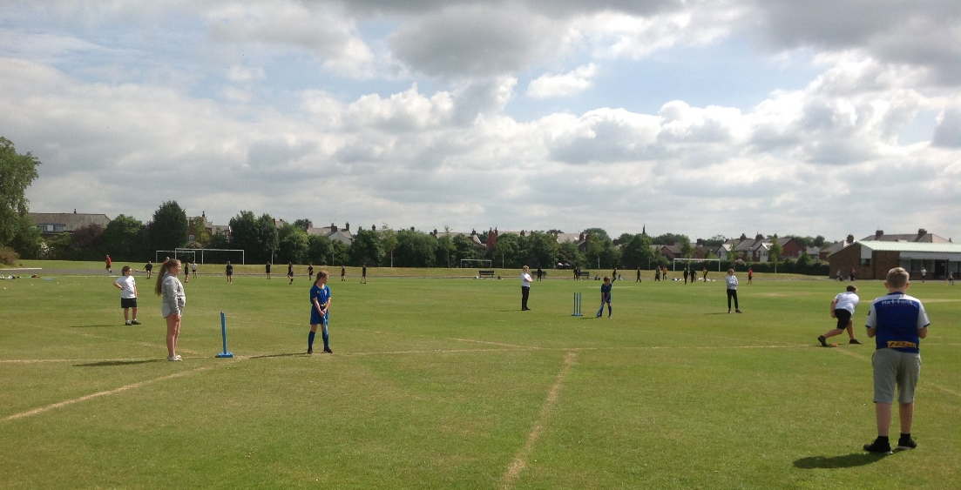
Rivington 24
Allanson Street 17

Rivington 7
Rainford Brook Lodge 21

