History Curriculum

EYFS
- Begin to describe a sequence of events, using words such as ‘first, then’.
- Describe events in some detail.
- Begin to make sense of their own life story and family’s history.
- Describe jobs that people do and why they are important.
- Listen to and talk about stories to build familiarity and understanding.
- Talk about the similarities and differences between things in the past and now.
- Talk about significant people and events in the past.

Autumn | Spring | Summer
Unit Title: All About Me – families, role and personal history  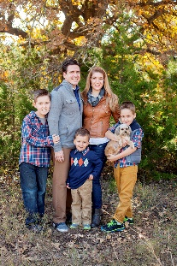  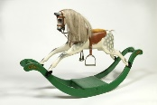 | 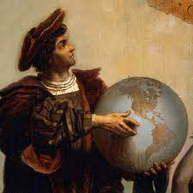  Unit Title: Traditional Tales/ Growth  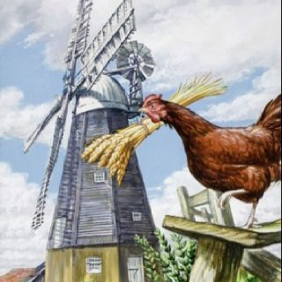 | Unit Title: Journeys/transition  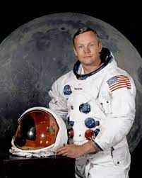  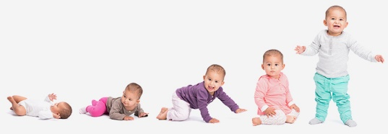
Prior Knowledge:  - I know who is in my immediate family.  - I know that I used to be a baby.  - I know that I am 3/4 years old now.  - I can say retell an event or story. | Prior Knowledge:  - I can name some people in my family and talk about their roles – mum, nan collects me etc.  - I can say why I am special.  - I can talk about the jobs of some of the people I know. | Prior Knowledge:  - I can describe a sequence of events, using words such as ‘first, then’.  - I can talk about past and present events in my own history.  - I can talk about people who lived in the past.  - I can listen to and talk about stories to build familiarity and understanding.
Prior Vocabulary:  - Now  - Before  - After | Prior Vocabulary:  - Before  - Yesterday  - Last week  - Last night | Prior Vocabulary:  - Past  - Old  - Long time ago  - Then
Skills:  - Can I talk about myself and the people that I know?  - Can I talk about the jobs of the people that I know?  - Can I say why I am special? | Skills:  - Can I talk about past and present events in my own life?  - Can I talk about events that have happened in nursery/reception?  - Can I talk about how people lived in the past? | Skills:  - Can I talk about myself as a baby?  - Can I compare myself now to when I was a baby?  - Can I talk about how I have changed since I started in September?  - Can I talk about significant people and events in the past?  - Can I sequence some historical events?  - Can I recall some events in detail?
Knowledge:  - To know that I am unique – I have similarities and differences to other people in my life.  - To know that people’s families are different.  - To know that people have different jobs and roles. | Knowledge:  - To know the vocabulary to describe when things happened in the past – yesterday, last week etc.  - To know that we can remember things that happened to us a long time ago.  - To know that things were different in the past – e.g. our parents/grandparents didn’t have mobile phones/Televisions looked different. | Knowledge:  - To know that things happen in an order and can be sequenced.  - To know that I was a baby and I have grown bigger and learnt to do lots of new things.  - To know that people change as they get older.  - To know that we can find out about things that happened in the past by looking in books, online or asking other people.
Key moments in big book:  - Timeline of activities in class  - Family photos/baby photos | Key moments in big book:  - Timeline of activities in class  - Children’s reflections on work from previous term  - Traditional tale – chn’s exploration of objects from the past | Key moments in big book:  - Timeline of activities in class  - Children’s reflections on work from previous term  - Comparison of September-June work
Focus Piece of Writing/Text:  - Mark making on portraits/family picture. | Focus Piece of Writing/Text:  - Draw and label items from story | Focus Piece of Writing/Text:  - Drawing/writing about what they have learnt – I can… now.
Key Vocabulary:  - Then  - Now  - Before  - Old  - Last week  - Last night  - Yesterday | Key Vocabulary:  - Past  - Long time ago  - Then  - Old | Key Vocabulary:  - Past  - Long time ago  - Then  - History  - Compare  - Change
Curriculum links:  - Literacy  - Communication and language  - Expressive arts and design | Curriculum links:  - Literacy  - Communication and language  - RE | Curriculum links:  - Geography  - Literacy  - Communication and language

