Geography Curriculum

EYFS

Autumn | Spring | Summer
Unit Title: All around us  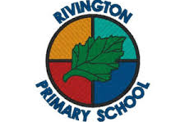  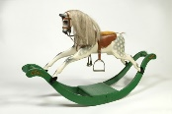  s | 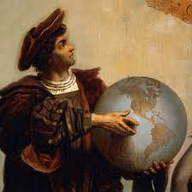  Unit Title: Weather and seasons  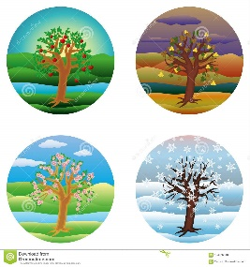 | Unit Title: Holidays  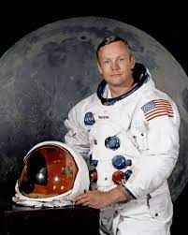  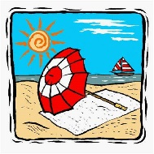
Prior Knowledge:  - I know that I attend Rivington Primary School  - I know how I travel to school (walk, car). | Prior Knowledge:  - I can use my senses to explore.  - I can comment on what I can see, hear and feel. | Prior Knowledge:  - I know that a map shows us where something is.  - I can say what the weather is like where I live.  - I know some ways to travel.
Prior Vocabulary:  - Place  - Home  - School  - Nursery | Prior Vocabulary:  - Cold  - Wet  - Rain  - Snow  - Sun  - Hot  - Ice  - Wind | Prior Vocabulary:  - Weather  - St Helens  - Travel  - Journey
Skills:  - Can I talk about where we live?  - Can I say how I travel to school?  - Can I name my street and door number?  - Can I identify areas from the school on a simple map? | Skills:  - Can I talk about what I see?  - Can I use vocabulary related to the weather – icy, frozen, melting etc?  - Can I comment on the weather changes and give a reason? e.g. the snow is melting because the sun is out.  - Can I name the seasons? | Skills:  - Can I talk about the differences I notice between countries when looking at photos or non-fiction books?  - Can I talk about ways to travel to other places and countries?  - Can I recall a trip I have taken – holiday or day out?
Knowledge:  - To know that we live in St Helens  - To know that there are different places to live and visit e.g. Liverpool.  - To know our school has different parts and we can move around from one place to another.  - To know that a map shows us where things are in a location. | Knowledge:  - To know that there are 4 seasons.  - To know that the weather is different in each season.  - To know that snow and ice are cold and we need to wear warmer clothes in this weather.  - To know that the sun can be hot in summer and we can wear lighter clothes and sun cream to protect ourselves. | Knowledge:  - To know that there are different countries in the world.  - To know that countries have differences – weather, food, clothing, money, languages etc.  - To know that we can locate countries on a map.
Key moments in big book:  - Exploring the school environment.  - Creating and using school maps. | Key moments in big book:  - Exploring weather  - Making rain gauges and wind catchers | Key moments in big book:  - Camping in the garden  - Travelling on ‘holiday’ in CP
Focus Piece of Writing/Text:  - Mark making maps | Focus Piece of Writing/Text:  - Drawing the weather scene | Focus Piece of Writing/Text:  - Drawing/writing about a holiday or place to visit.
Key Vocabulary:  - Map  - Area  - Town  - Address  - Travel | Key Vocabulary:  - Weather  - Season  - Winter, Spring, Summer, Autumn  - Changes  - Weather vocab (hot, cold, freeze, storm etc) | Key Vocabulary:  - Country  - Map  - Travel  - Journey  - Sea/ocean  - Land
Curriculum links:  - Literacy  - Communication and Language  - PSE | Curriculum links:  - Science  - Communication and language  - Maths | Curriculum links:  - Science  - Literacy  - Communication and language

