Sutton Academy
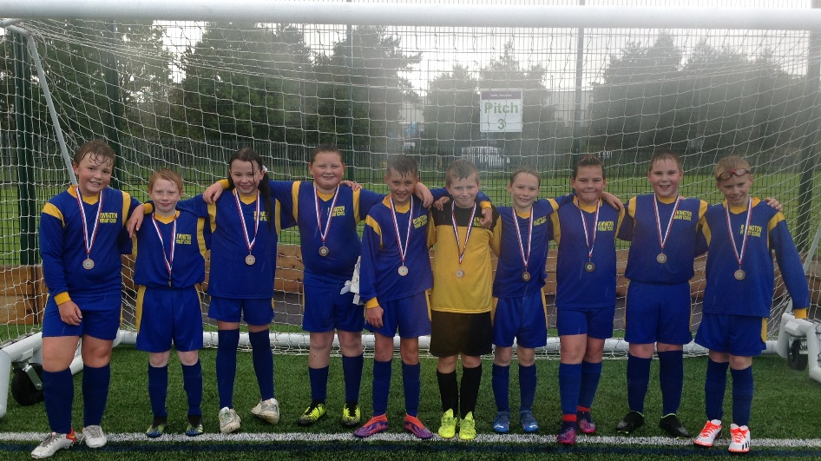
Y6 Football Tournament
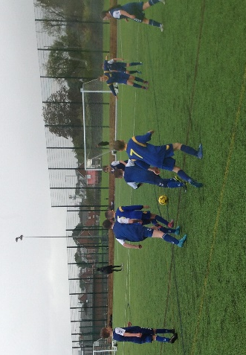
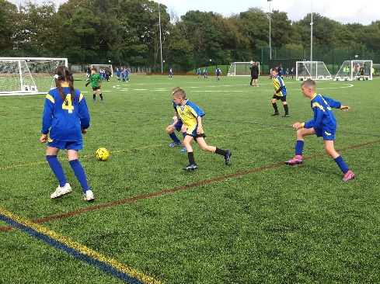
Well done to our Year 6 Football team who represented the school at the St Helens Schools Football Tournament at Sutton Academy on Wednesday. All the children played really well and demonstrated great sportsmanship, determination, perseverance and resilience throughout the tournament. The children made it into the semi-finals of the tournament and ended up finishing in third place, which is an amazing achievement.
