Saints Sky Try Rugby League Tournament
19th October 2016
Some of our children in Year 4 represented the school at this year’s Sky Try Rugby League tournament on Wednesday 19th October at Cowley International College. We had two rugby teams enter into the tournament this year and both teams played extremely well with great team spirit. Both teams were unbeaten throughout the tournament and demonstrated great enthusiasm and determination.
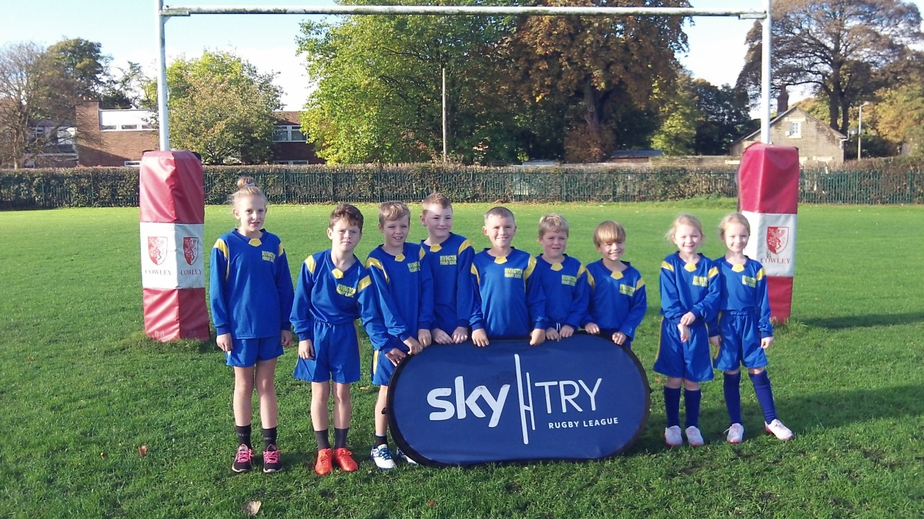

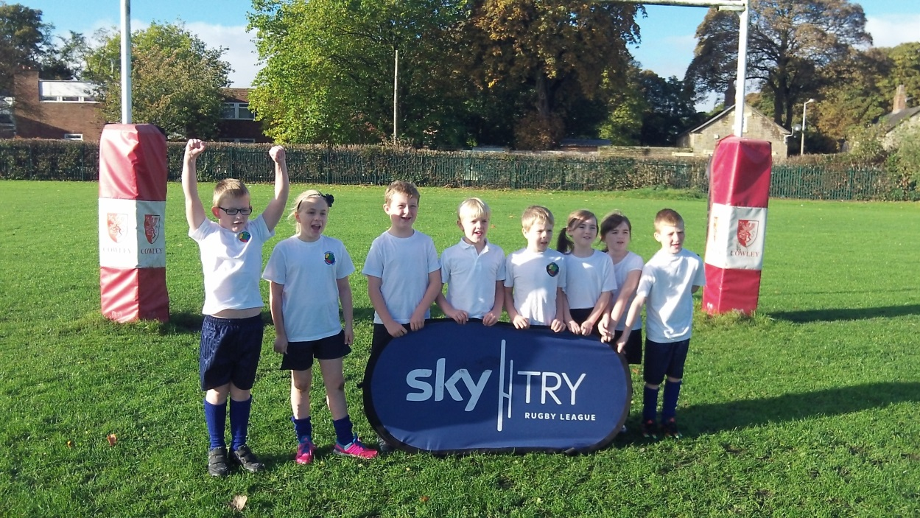
Rivington Blue Team
Rivington White Team

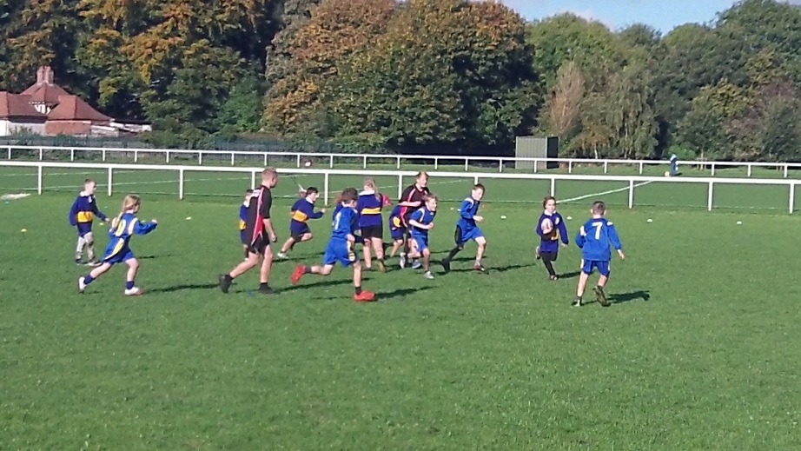
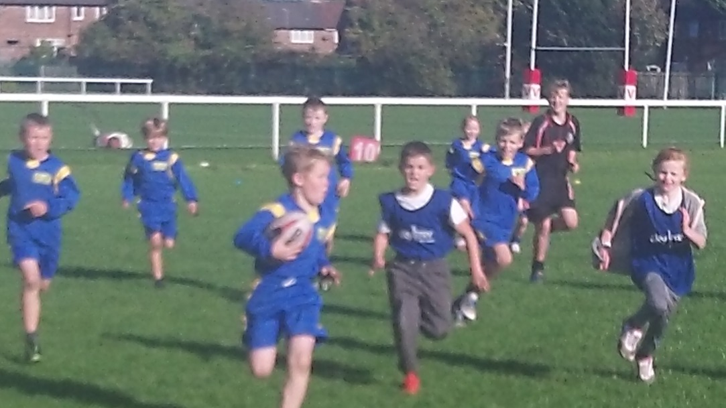
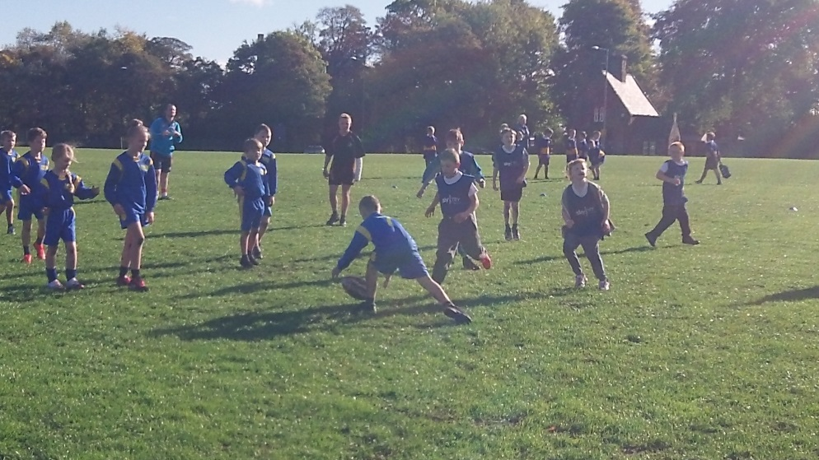
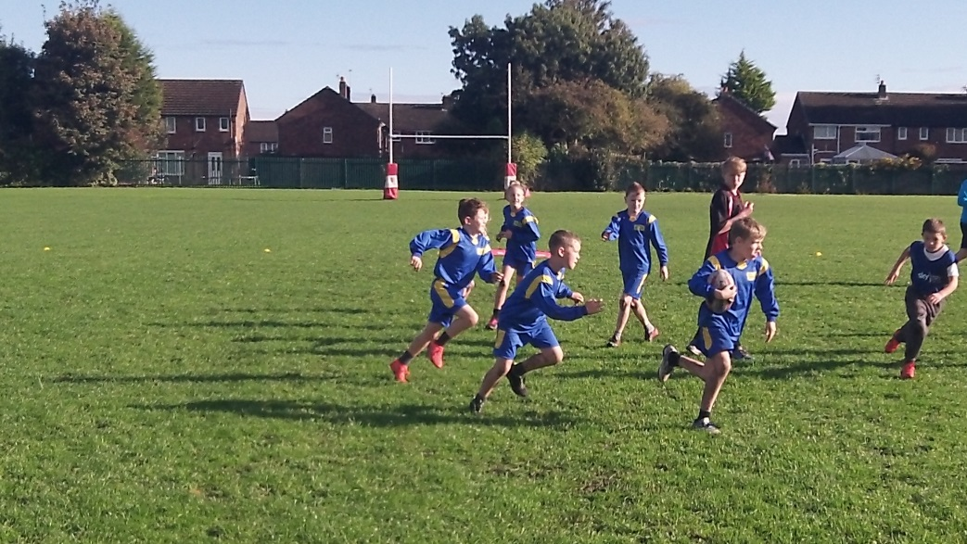
Connor was our ‘Player of the Tournament’ today for demonstrating great sportsmanship and actively working to include everyone in the team.
Our blue team played fantastically well and managed to win every game.
Well done to both teams for doing so well throughout the tournament. All the children are to be congratulated for their excellent attitudes and behaviour.

