Woodlands Cup Tournament
6th October 2016
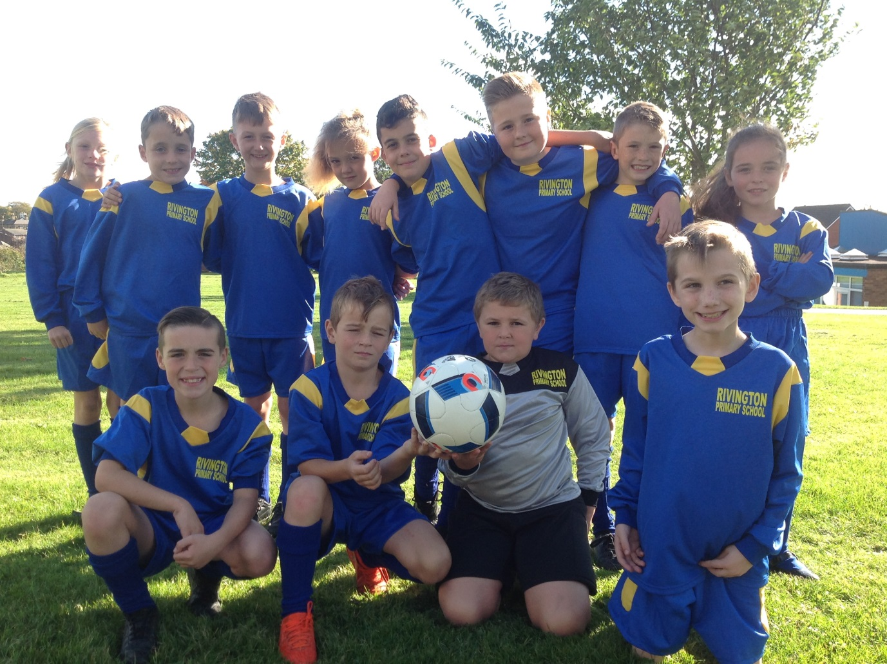
We were proud of our football team and their performance in the Woodlands Cup at Clinkham Woods on Wednesday. The team played really well in all its matches in the group stages, however, a few last minute goals from our opponents resulted in us not making the semi finals this year. All the children thoroughly enjoyed themselves and are looking forward to future matches.
Mr Veitch chosen George as his most improved player in today’s competition and the Player of the Match, which is voted for by all the players, went to Kian.
Well done Kian and George!
