KS1
- to use a range of materials creatively to design and make products.
- to use drawing, painting and sculpture to develop and share their ideas, experiences and imagination.
- to develop a wide range of art and design techniques in using colour, pattern, texture, line, shape, form and space.
- about the work of a range of artists, craft makers and designers, describing the differences and similarities between different practices and disciplines, and making links to their own work.
Autumn | Spring | Summer
Unit Title: Local History – Skyline/Horizon Drawing  If the artist visited St. Helens, what would he draw? | Unit Title: Colour - Animals and their habitats  Traditional tales | Unit Title:  Fabric and paper collage – Kinetic artwork/animation
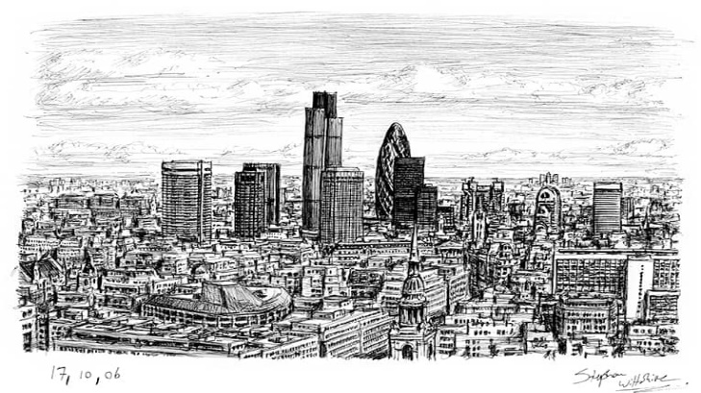  Artist: Stephen Wiltshire  https://www.stephenwiltshire.co.uk/london-skyline-panorama-drawing | Artist:  Maria Sibyla Merian  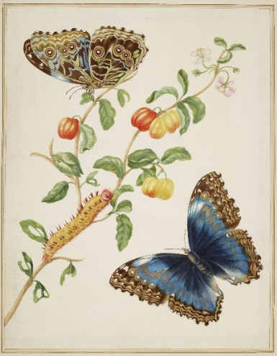  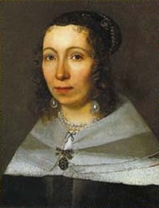 | Artist:  Beatriz Milhazes – link to tech with moving parts.  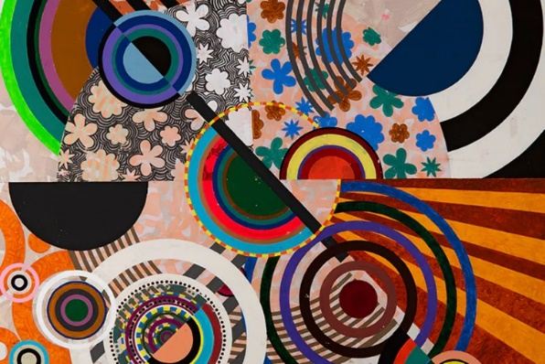  Jess Wheeler  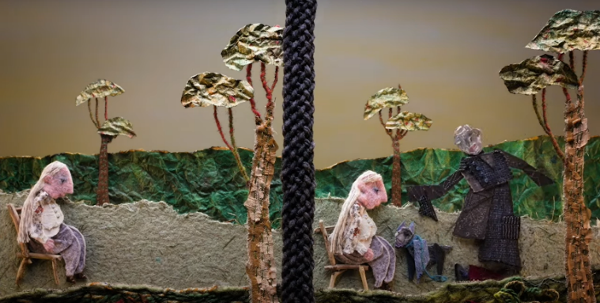
Prior Knowledge:  - I can make a variety of marks with a pencil.  - I can hold my pencil in different ways to make different marks.  - I can produce an observational drawing of a subject.  - I can create a piece of artwork inspired by another artist.  Prior Vocabulary:  Draw, angle, perspective, shape, composition. | Prior Knowledge:  - I can use my finger to apply paint to paper in different ways.  - I can create prints of my own hand using paint.  - I can select appropriate colours for different paintings.  - I can create prints of different objects using paint.  - I can create prints of natural objects using paint.  - I can select appropriate colours for a desired effect.  - I can explore different colours in an artwork.  - I can experiment with different arrangements and colour.  - I can recognise Primary colours and use them to mix secondary colours.  - I can identify warm and cold colours.  - I can make different marks on paper using paint.  - I can experiment with different 2-dimensional arrangements and colour.  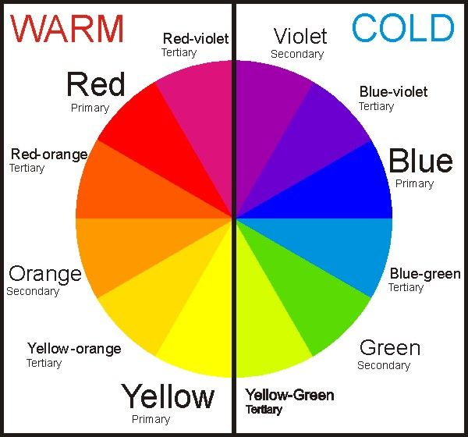  Prior Vocabulary:  Primary, secondary, mixing, pattern, pressure, design, effect. | Prior Knowledge:  - I can arrange objects to create an effective composition.  - I can combine collage and drawings in one artwork.  - I can select appropriate colours for different paintings.  - I can create prints of different objects using paint.  - I can select appropriate colours for a desired effect.  - I can explore different colours in an artwork.  - I can experiment with different arrangements and colour.  - I can recognise Primary colours and use them to mix secondary colours.  - I can identify warm and cold colours.  - I can make different marks on paper using paint.  - I can experiment with different 2-dimensional arrangements and colour.  Prior Vocabulary:  Paint, print, draw, shape, pencil, colour, sculpture, objects, colour, autumn, arrange, create, similar, cut, stick, arrange, collage, design, effect, composition, layer, combining, pattern, primary, secondary, tertiary.
Skills:  - Can I make a variety of marks with pencil and ink?  - Can I produce an accurate observational drawing from a photograph?  - Can I consider proportion in my drawing?  - Can I combine different drawings to create one composition? | Skills:  - Can I recognise different tones of one colour (tertiary)?  - Can I mix secondary colours effectively using paint?  - Can I experiment by adding water to make the paint less opaque?  - Can I blend colours effectively when using paint, coloured pencils and pastels? | Skills:  - Can I cut and tear materials with accuracy?  - Can I combine different materials effectively in one artwork?  - Can I include a variety of textures in my collage?  - Can I add moving elements to my collage?
Knowledge:  - To that Stephen Wiltshire MBE, is a British architectural artist and autistic savant. He is known for his ability to draw a landscape from memory after seeing it just once.  - To know the key landmarks that make up the skyline of St. Helens and where they are located on a skyline.  https://www.sthelenscommunityarchive.org.uk/archive | Knowledge:  - To know that Maria Sibylla Merian  (2nd April 1647 – 13th January 1717)  was a German-born naturalist and scientific illustrator. Merian was one of the early European naturalists to observe insects directly.  - To know how to blend colours seamlessly. | Knowledge:  - To know that Beatriz Milhazes is a Brazilian artist. She is known for her work combining Brazilian cultural imagery and references to western Modernist painting.  - To recognise the different textures in animation by the artist Jessica Wheeler and how she uses these textures to emphasise movement in her work.  - To know what a kinetic artwork is.
Key moments in sketchbook:  - Artist Research pages – Stephen Wiltshire  - Experimenting with mark-making using pencils and ink.  - Exploratory drawings of St. Helens landmarks from photographs.  - Combining pen and pencil in one artwork.  - Combining drawings to create a panoramic skyline.  - Experimenting with layout, composition and scale.  NB – Annotation should feature throughout the sketchbooks to show the pupils’ reflections on their work and that of others. | Key moments in sketchbook:  - Artist Research pages – Maria Sibylla Merian.  - Exploratory drawings of plants and insects.  - Experiments with watering down paint and using colour washes.  - Experimenting with blending colours (paint, coloured pencils and pastels).  - Different arrangements for a final composition  - Photo of final artwork  NB – Annotation should feature throughout the sketchbooks to show the pupils’ reflections on their work and that of others. | Key moments in sketchbook:  - Artist Research pages – Beatriz Milhazes and Jess Wheeler.  - Exploratory drawings and paintings of different shapes and combinations of materials.  - Experiments with creating moving parts.  - Experimenting with blending colours (paint, coloured pencils and pastels) when creating different elements for a final piece of artwork.  - Different arrangements for a final composition.  - Photo of final artwork  NB – Annotation should feature throughout the sketchbooks to show the pupils’ reflections on their work and that of others.
Final artwork:  Panoramic artwork | Final artwork:  A3 size artwork in the style of Maria Sibylla Merian and including facts about the plants and insects depicted. | Final artwork:  Individual or large collaborative artwork featuring moving parts, geometric shapes and different textures.  Extension: Animated film of moving artwork.
Key Vocabulary:  View, skyline, landmarks, accurate, observation, panorama, scale, proportion. | Key Vocabulary:  Accurate, wash, tertiary, opaque, blend, seamless, observation. | Key Vocabulary:  Movement, kinetic, combine, texture, clashing colour/pattern, bold, busy.
Curriculum links:  Geography – St. Helens | Curriculum links:  Science – plants and insects | Curriculum links:  DT – moving parts.  Geography – Brazilian artist (where is Brazil on a globe?)

