
Rivington Primary School
Newsletter
www.rivingtonprimary.co.uk

Friday 6th November 2015

November:

9th Y4 Swimming
13th Y5 & Y6 NSPCC workshops
16th Y4 Swimming
19th Return School Photo orders
23rd Y4 Swimming
26th Christmas Coffee Afternoon
27th School nurse drop in-8.30am
30th Y4 Swimming
Rec trip to Central Station

December:

8th KS1 Christmas performance 2pm
9th Christmas Dinner
KS1 Christmas performance 6.30pm
11th Foundation Stage performance
14th Y4 Swimming
15th KS1 Christmas Party
16th Y3 & Y4 Christmas Party
17th Y5 & Y6 Christmas Party
18th School nurse drop in-8.30am
End of term

We returned to school after the Autumn break to our busy but exciting Christmas Term.

Our school photos have been taken and everyone looked very smart (see note below about orders).

We are launching a new ‘Smart Class Award’ next week to celebrate all the children who come in uniform every day (see details on the next sheet).

We also had our second coffee morning where there were some delicious cakes! Nursery and Reception held a small 5th November Party which was very exciting.

We are currently planning our Christmas Event and a letter will come out next week about this.

Weekly Attendance Awards
Week commencing 19th October 2015

Congratulations to our Y4 class who had 99.7% attendance - a great achievement.

It’s encouraging to see such
great punctuality and attendance!

SCHOOL PHOTOS

Proofs have been sent home this week. Please return your orders to the School office by Thursday 19th November. We are unable to take any orders after this date.
Thank you



TUCK MONEY

Please remember that there is a 50p limit at the Tuck Shop. The food that we sell is reasonably priced and the children can get a decent snack with just 50p.

Thank you.

We have had several complaints from parents and staff who have witnessed bad language on the school grounds.
Please use appropriate language at all times so we can set a good example to the children.

2015 Poppy Appeal
Poppies are still on sale in the office. There is also a selection of other items on sale in the school office, including wrist bands, reflectors and pencils. Recommended donations for these items range
from 50p to £1.
From next week we are going to introduce the ‘Smart Class Award’ to celebrate how smart our children look and reward those who wear their uniform every day. Children will be awarded daily points for wearing correct uniform. This will be as follows:

- Sensible black shoes
- Grey/black trousers, grey skirt/pinafore
- White shirt, grey jumper/cardigan
- The school badge on either jumper or polo shirt
- General to include: no additions e.g. jewellery (including uncovered earrings), temporary tattoos, long hair tied back neatly.

This means every child can be awarded 5 points a day/75 points a week. The class with the most points (with adjustments for numbers of children) will be awarded the trophy for the week. As part of our consultation last year parents wished for recognition for those who always wear uniform. If however you have problems with sending your child in the correct uniform please let the class teacher know as there are things we can do to help.

Thank you!

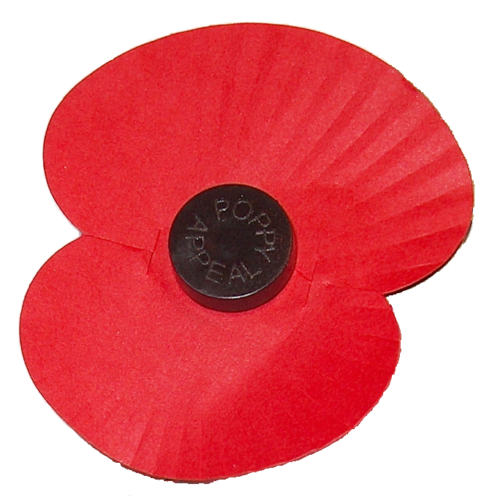

We are still collecting tokens for Tubs4Tablets. If you have any at home please send them in to school.
Thank you




