Gymnastics Competition
6th March 2019
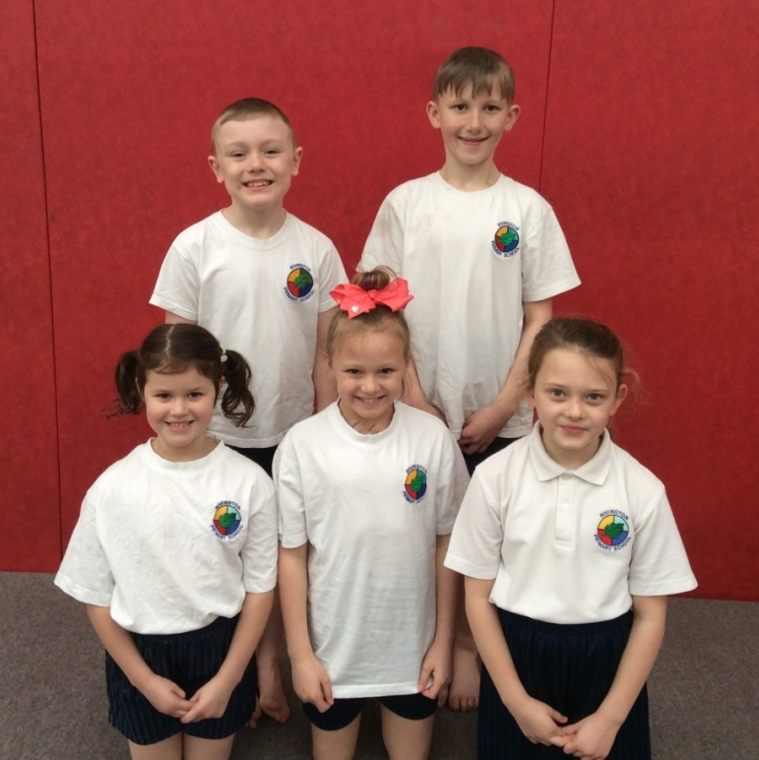
On Wednesday 6th March, five children from Years 3 and 4 were selected to take part in a gymnastics competition at St Helens Centre of Gymnastics. The children competed as a team against other schools from across St Helens. The children had to complete a floor routine, body management exercises and then the vault for the judges, who scored them for each performance. All of the children really enjoyed a fun and energetic morning showing off their gymnastics skills and were a credit to our school. Well done to all of the children involved.

