RIVINGTON PRIMARY SCHOOL

British Values

We invite you to come on an exciting learning journey.
Discover, create, invent, explore. Join the adventure …….

Reviewed Autumn 2018

At Rivington Primary School British values underpin everything that we do.
Democracy
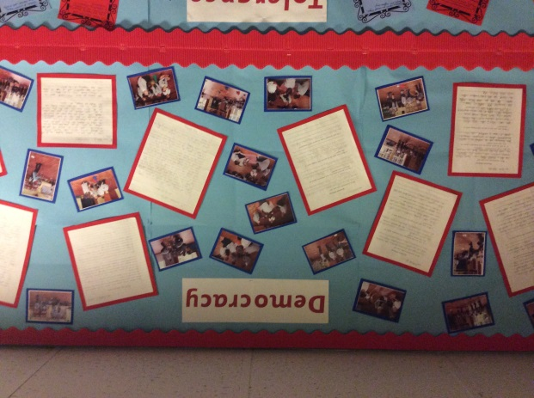
We ensure that all children have a voice and the understanding that they have the right to be heard. We do this by having a school council, voting of house captain, making decisions about the school environment (designing garden, bridge, school sign, and badge) children experience organised democratic debates at the Town Hall.
From an early age children are involved in circle time that encourages them to talk about their feelings.
Children are given opportunities to voice their opinions and as they get older they can take part in debates and put forward different point of view.

Rule of Law
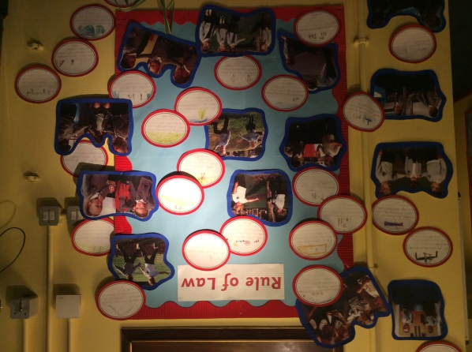
In school we talk about the importance of laws and how they govern and protect us. Children are taught the importance of rules. Our school rules have been written by the whole community and we have a version the children wrote themselves.
Every class at the beginning of the school year collaborates with staff to agree a set of class rules. Rules shared with parents. Children understand the consequences of breaking these rules and discussions around making the right choices. Good behaviour is rewarded through merits.

Individual liberty/freedom
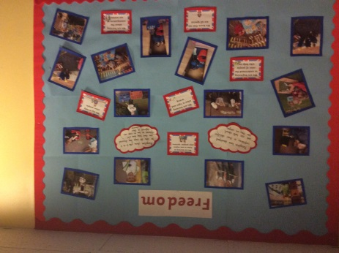
Staff provide opportunities through the curriculum to develop self-esteem and confidence in their own ability by allowing them to take risks and talk about their learning. We encourage them to understand that their choices will affect others and we celebrate everyone’s success.
We help them to make choices in a safe and controlled environment. This is also supported by our programme of enrichment and extra-curricular activities which enable children to explore their own interests.
Mutual Respect
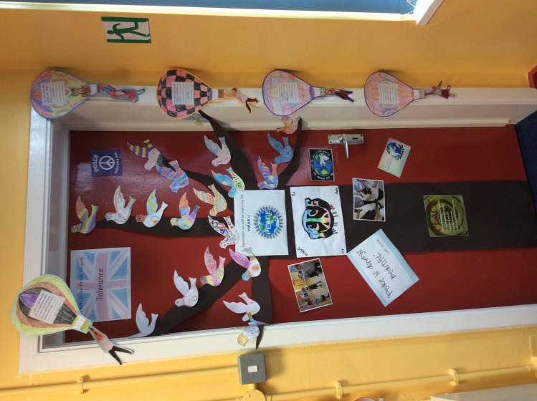
Our children are encouraged to be respectful of each other and of the community as a whole. We promote collaborative group work and teach children the skills needed to work together.
The story of the elephants which came from the children promotes the family ethos of the school and celebrates the way the older children look after the younger ones.
Children are taught that they don’t always have to agree with each other to get along but they need to respect each other’s views if we want to live together in peace.

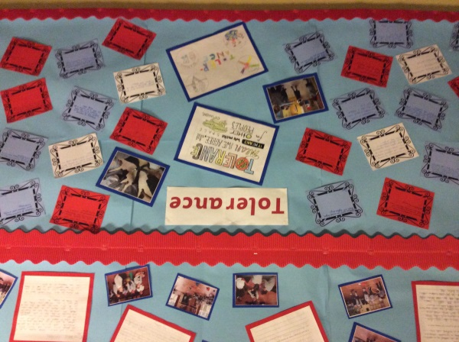
Mutual Respect & Tolerance
We promote an acceptance that everyone has different ideas of faith and beliefs and it is important to respect this. We do this through learning about different celebrations, religions and traditions, which then promotes diverse attitudes and challenges stereotypes.
We follow the St Helens agreed syllabus for Religious Education where the children learn to respect a wide range of religious beliefs.
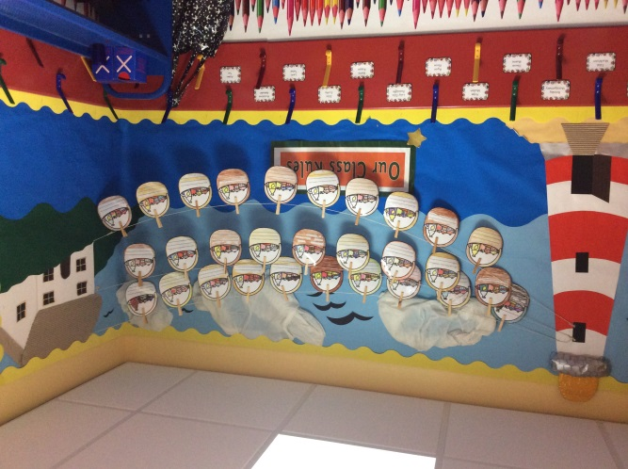
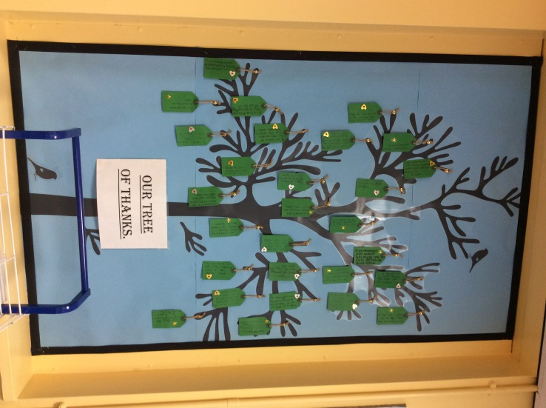

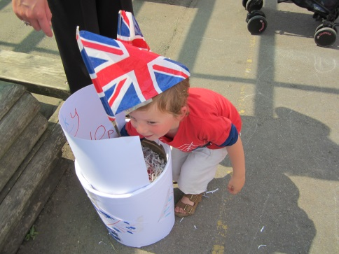
Our British Values are reinforced in our lessons, assemblies and through special events. We have a Summer Event which has a Great British Theme every two years.
