Sportshall Athletics
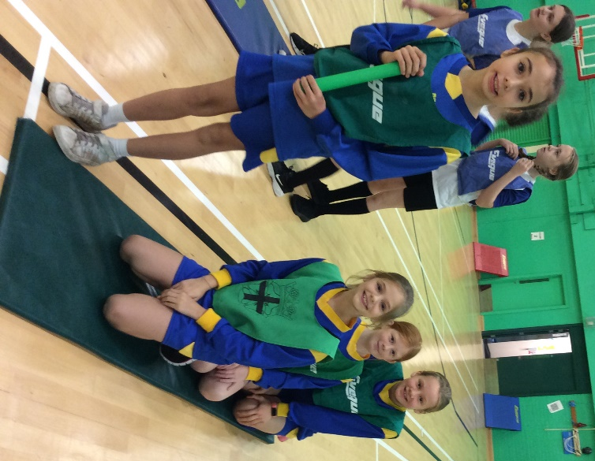
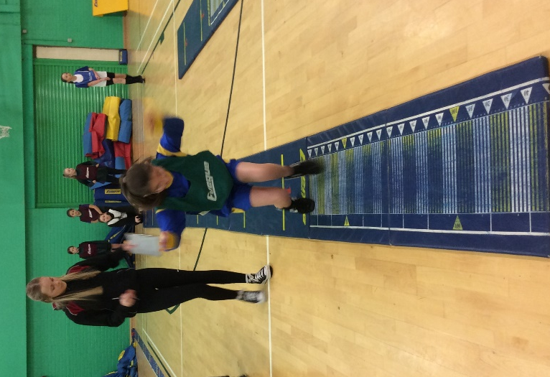
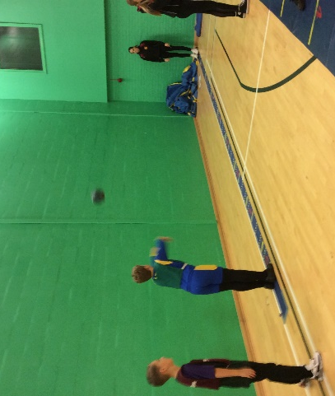
On Friday 18th November our Y5/Y6 Athletics team went to compete at Broadway’s Sportshall Athletics Competition. They took part in a range of events such as the long jump, sprint, relay, triple jump and javelin. Everyone in the team tried their best at each event and all the children represented the school brilliantly.

