Science Curriculum
EYFS
- Explore collections of materials with similar and or different properties.
- Use all senses in hands on exploration
- Explore the natural world around them
- Describe what they see, hear, feel when outside
- Begin to understand the need to respect and care for the natural environment and living things
- Plant seeds and care for growing plants.
- Understand the key features of the life cycle of a plant and an animal
- Explore the natural world around them, making observations and drawing pictures of animals and plants (ELG)
- Understand some important processes and changes in the natural world around them, including the seasons and changing states of matter (ELG)

Autumn 1 | Autumn 2 | Spring 1 | Spring 2 | Summer 1 | Summer 2
Unit Title: Ourselves  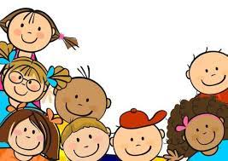 | Unit Title: Autumn  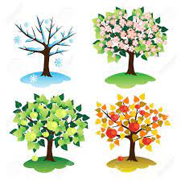 | Unit Title: Winter  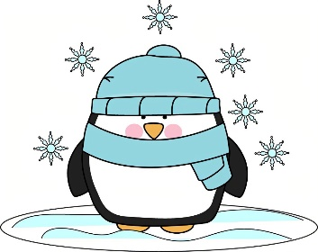 | Unit Title: Growth  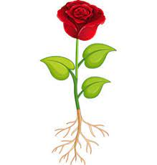 | Unit Title: Life Cycles  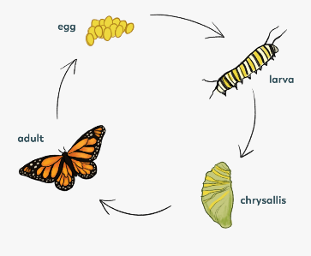 | Unit Title: Change  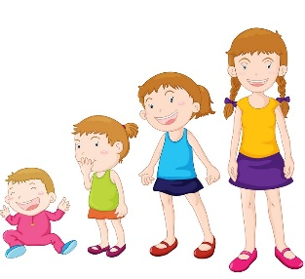
Prior experience:  - Use all of the senses in hands on exploration. | Prior experience:  - Use all of the senses in hands on exploration.  - Notice things that are the same and different. | Prior experience:  - Use all senses in hands on exploration of natural materials.  - Talk about what they see, hear and feel. | Prior experience:  - Explore the natural world around them.  - Make drawings of things they have noticed in the environment. | Prior experience:  - Explore the natural world around them.  - Make observations of things they have noticed.  - Plant seeds and care for growing plants. | Prior experience:  - Comment on changes they have noticed in the environment.  - Notice seasonal changes.  - Comment on changes in the life cycle of a plant or animal.
Prior Vocabulary:  - Family  - Baby | Prior Vocabulary:  - touch, see, hear, smell, taste.  - Weather | Prior Vocabulary:  - Autumn  - Weather  - Cold  - Leaves  - Conker  - Dark | Prior Vocabulary:  - touch, see, hear, smell, taste. | Prior Vocabulary:  - Baby  - Grow | Prior Vocabulary:  - Basic body parts – hair, nose, ear, eye, neck, chest, wrist, hand, knee, foot, head, eyebrow, mouth, chin, shoulder, elbow, arm, stomach, leg, ankle.  - touch, see, hear, smell, taste.  - Baby, child, adult  - Grow, change
Skills:  - Can I name some body parts?  - Can I compare myself to somebody else (I have blue eyes, he has brown eyes)?  - Can I say who is in my family?  - Can I use my senses to explore? | Skills:  - Can I comment on what I notice in the environment?  - Can I say what has changed e.g. the tree has no leaves now.  - Can I use my senses to explore? | Skills:  - Can I explore ice and comment on what I notice as it changes?  - Can I describe the weather? | Skills:  - Can I plant seeds and water them?  - Can I describe what I see as the plants grow?  - Can I say that living things grow and need to be cared for? | Skills:  - Can I describe what I see and comment on changes?  - Can I recognise the changes to a caterpillar as it grows?  - Can I make observational drawings of what I see? | Skills:  - Can I comment on how I have changed?  - Can I comment on what I see, hear, taste, smell and touch?  - Can I make observational drawings of what I see? (summer – trees, plants etc).
Knowledge:  - To know that I have body parts that can do different things e.g. legs help me to walk.  - To know that we can hear, see, touch, taste and smell. | Knowledge:  - To know that leaves fall off trees in the autumn.  - To know that the weather gets colder and the nights become darker. | Knowledge:  - To know that weather in winter can be very cold.  - To know that water can freeze and ice can melt. | Knowledge:  - To know that plants grow and change.  - To know that seeds can be planted in soil.  - To know that living things need to be cared for. | Knowledge:  - To know that all living things grow and change.  - To know that an adult of a species does not always look the same as the baby. | Knowledge:  - To know that people change and develop in different ways.  - To know that plants bloom in summer.  - To know that the weather is summer can be hot.
Key moments in big book:  - Self portrait  - Exploring themselves and their bodies | Key moments in big book:  - Photographs of autumn walks  - Tree/leaf rubbing | Key moments in big book:  - Photographs of winter exploration  - Photos of melting/freezing experiment | Key moments in big book:  - Photographs of planting  - Drawings of plant growth | Key moments in big book:  - Photographs of caterpillar eggs and butterfly  - Drawings of observations | Key moments in big book:  - Child’s voice in big book reflecting on how they have changed since the start of the year.
Focus Piece of Writing/Text:  Self-portrait and name writing  My family… | Focus Piece of Writing/Text:  Autumn drawing and mark making  I can see… | Focus Piece of Writing/Text:  Labelling winter pictures and polar animals. | Focus Piece of Writing/Text:  Plant growth observation notes.  Labelling plant parts. | Focus Piece of Writing/Text:  Labelling life cycle.  Notes on drawings of observations – ‘caterpillar egg’. | Focus Piece of Writing/Text:  Self-portrait and observations - I can now…
Key Vocabulary:  - Basic body parts – hair, nose, ear, eye, neck, chest, wrist, hand, knee, foot, head, eyebrow, mouth, chin, shoulder, elbow, arm, stomach, leg, ankle.  - touch, see, hear, smell, taste. | Key Vocabulary:  - Autumn  - Weather  - Cold  - Leaves  - Conker  - Dark | Key Vocabulary:  - Ice  - Snow  - Freeze  - Melt  - Winter  - Polar | Key Vocabulary:  - Plant  - Grow  - Seed  - Water  - Sun  - Stem, leaf, flower  - Spring | Key Vocabulary:  - Grow  - Change  - Baby  - Adult  - Develop | Key Vocabulary:  - Same  - Different  - Change  - Develop  - Summer  - Hot  - Melt
Curriculum links:  PSHE – ourselves, families. | Curriculum links:  CL – language development and listening walks | Curriculum links:  Geography – cold countries | Curriculum links:  Maths – plant growth | Curriculum links:  Lit – linked text | Curriculum links:  CL/PSE – ourselves

