St Helens School Nursing Service Newsletter

Summer Edition 2016



Welcome to the 3rd edition of the St Helens School Nursing Service Newsletter.

This is for children, young people, families and schools in St Helens.

Who are we? What is our role?

School Nurses are public health nurses who lead and deliver the Healthy Child Programme for school aged children and young people.

We promote your health and wellbeing with a focus on early help and prevention. We also support and address any health needs that may affect young people.

Every child and young person who attends school, an educational provision or is home educated in St Helens, will have a named School Nurse who is supported by their team.

Did you know….?

Some of our School Nurses have moved to other clinics. The School Nurses that were originally based at The Bowery Clinic or Rainhill Clinic are now located at Irwin Road Clinic or Newton Clinic. Please see our up to date information for contact details.



|  |  |  |
| --- | --- | --- |
| Sarah Logan | Cowley International College  Queens Park Primary | Billinge Clinic, Rainford Road, Billinge WN5 7PF  01744 624350 |
| Gemma Conway | Bleak Hill Primary  St Teresa’s  Rainford C/E Primary  Brook Lodge Primary  Corpus Christi Primary  Rivington Primary  Garswood Primary  Youth Offending Team | Billinge Clinic,  Rainford Road,  Billinge  WN5 7PF  01744 624350 |
| Julia Walsh | Chapel End  Holy Cross  Parish Church  St Aidans  St Peter & St Pauls | Billinge Clinic, Rainford Road, Billinge WN5 7PF  01744 624350 |
| Victoria Waters | Rainford High School  St Thomas of Canterbury  Rectory  Carr Mill Primary  St Marys | Billinge Clinic, Rainford Road, Billinge WN5 7PF  01744 624350 |
| Judith Foster  Gill Lucas | Alternative Education  Home Educated  Penkford | Newton Community Hospital  Bradlegh Rd  Newton le Willows  0151 290 4051 |
| Joan Atkinson | Hope Academy  District Primary  Wargrave Primary | Newton Community Hospital  Bradlegh Rd  Newton le Willows  0151 290 4051 |
| Mike Delooze | St James  English Martyrs  Newton Primary  Grange Valley  Lyme Primary | Newton Community Hospital  Bradlegh Rd  Newton le Willows  0151 290 4051 |
| Tracy Fairhurst | St Augustine  Ashurst Primary  Blackbrook St Marys  (special school cover) | Newton Community Hospital  Bradlegh Rd  Newton le Willows  0151 290 4051 |
| Catherine Prescott | Haydock High School  Legh Vale  St Peters (Newton)  St Mary’s (Newton) | Newton Community Hospital  Bradlegh Rd  Newton le Willows  0151 290 4051 |



|  |  |  |
| --- | --- | --- |
| Debbie Stott | The Sutton Academy  Sutton Oak  Thatto Heath Primary | Irwin Road Clinic  Irwin Road  St Helens  WA9 3UG  01744 811592 |
| Naomi Lewis | St Cuthbert’s  Youth Offending Nurse | Irwin Road Clinic  Irwin Road  St Helens  WA9 3UG  01744 811592 |
| Sophie Hayworth | Rainhill High  Allanson Street  St John Vianney  St. Theresa’s  St Austins | Irwin Road Clinic  Irwin Road  St Helens  WA9 3UG  01744 811592 |
| Clare Bromiley | Broad Oak  Holy Spirit  Nutgrove Primary  Robins Lane | Irwin Road Clinic  Irwin Road  St Helens  WA9 3UG  01744 811592 |
| Bernie Jackson | De la Salle  St Julies  Eccleston Mere  St Bartholomew’s  Tower College (immunisations only)  Carmell College  Merton Bank | Irwin Road Clinic  Irwin Road  St Helens  WA9 3UG  01744 811592 |
| Donna Pimblett | Rainhill High  Sherdley Primary  Sutton Manor  Eaves Lane  Longton Lane | Irwin Road Clinic  Irwin Road  St Helens  WA9 3UG  01744 811592 |
| Julie Wells | St Mary and St Thomas  Willow Tree  St Ann’s  Oakdene  Eccleston Lane Ends | Irwin Road Clinic  Irwin Road  St Helens  WA9 3UG  01744 811592 |
| Tracey Gardner | Lansbury Bridge | Lansbury Bridge School, Lansbury Avenue, Parr, St Helens, WA9 1TB  01744 678579 |
| Linda Roberts | Mill Green | Lansbury Ave, Saint Helens WA9 1BU  01744 678760 |
| Louise Gettings | School Nurse - Allergy | Billinge Clinic,  Rainford Road,  Billinge  WN5 7PF  01744 624350 |

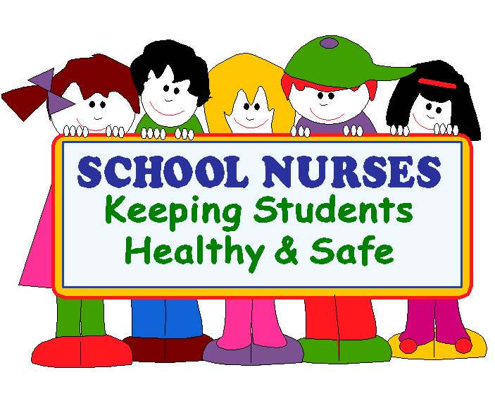

‘Drop in’

Every high school in St Helens has a confidential ‘drop in’ service for young people to use. ‘Drop ins’ are held every week and young people can talk to the named school nurse or one of the team in confidence.

What is meant by **‘Confidential’**?

* We will not disclose anything that has been discussed, with anyone else. Whilst it is a confidential service, we will encourage young people to discuss their concerns with their parent/guardian.

**We will only break confidentiality if we are concerned that the young person or someone else is at a significant risk of harm.**

Young people can come and talk to us about anything that is worrying them, like

* Keeping Healthy
* Immunisations
* Feeling Down
* Relationships

**And lots more…………………………! Please come and see us!**

Here is the list of our current ‘drop in’ locations.

|  |  |
| --- | --- |
| Cowley International College | Thursday 1.15 -2pm |
| De La Salle | Wednesdays 1-2pm |
| St Cuthberts | Tuesdays 1pm-1.30pm |
| Sutton Academy | Tuesday 1.05-1.35pm |
| St Augustines | Wednesday 1.05-1.35pm |
| Haydock High School | Wednesday 1-2pm |
| Rainford High Technology College | Wednesdays 12.45pm-1.30pm |
| Rainhill High School | Monday 12.15pm – 1pm |





Enjoy and be safe in the sun!

The summer months are coming so it is important to stay safe from the sun!

What is sunburn?

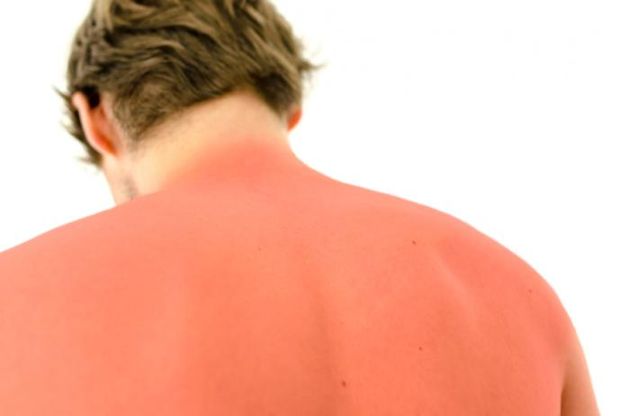Sunburn is damage to the skin by UV rays that the sun emits, this causes red, warm, tender, itchy skin lasting for about a week. However, in bad cases it can cause blisters and scaring.

Risks of being sunburnt as a child:

* A higher risk of skin cancer once you are an adult.
* A short term discomfort and pain.

Prevention at home and at school:

* Play in the shade between 11am and 3pm when the sun is at its hottest.
* Cover exposed areas of the skin including; Shoulders, nose, ears, cheeks and the tops of your feet.
* Wear either a high factor sun screen or a waterproof sunblock (If swimming) and keep reapplying throughout the day.
* Wear cotton clothes at home and either a baseball or floppy hat to protect the head, face and the back of the neck from burning. A hat and sunscreen can be put on before going to school also.

If you do get sunburnt there are a couple of things that could help to reduce your symptoms;

* Remove yourself from the sun as soon as possible.
* Drinking plenty fluids to avoid dehydration.
* Apply after sun or a petroleum jelly such as Vaseline to keep the skin moist and cool.
* Have painkillers such as Paracetamol and Ibuprofen.
* Finally, cover the burnt area until it is fully healed.

If you do get sunburnt, it is very important to prevent it happening in future or serious skin damage can be made! If you have any more questions or would like to talk about this please come and visit your school nurse at a drop in session, we are happy to help.

The Dangers of Open water swimming!

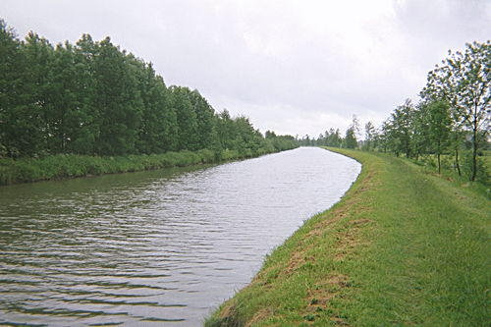

During the summer season’s children and young people think that swimming in open water such as; Lakes, Canal’s and Quarries is completely safe as the weather isn’t horrible. This isn’t true! It is known that a child can **drown** in only **5cm of water**! Drowning is also known to be the 3rd highest reason for death for people at your age!

The **dangers** of swimming in open waters:

* It is **very cold**, this can send the body into shock.
* There may be **hidden currents** that could lead to people drowning unexpectedly
* It can be **difficult to get out** due to slimmey banks.
* It can be **deep**, this can be a struggle if you aren’t a good swimmer!
* There could be **hidden rubbish** under the water i.e. broken glass
* There are **NO** lifeguards
* You can’t estimate the depth
* It could be **polluted** and could cause illness

If you decide to swim in open waters or you witness somebody swimming in open waters, think and ask if they know the dangers. Here are a couple of things to do and think about if you are near water with your friends;

* Constantly look for danger
* Never swim alone
* Check to see if there is any people around incase of an emergancy or bring an adult
* Check for tides or currents
* Think! Is there any rocks bathing or paddling?
* Think! Is this a restricted area?
* Think! What are the general condition in and out the water?

**If you find yourself in an emergancy follow these steps:**

Shout for help or assistance

Or

Ring 999 or 112

**BUT DO NOT ENTER THE WATER TO HELP ANYBODY. YOU WILL PUT YOURSELF IN DANGER.**

**Enjoy summer, but be safe!**

If you would like to speak to anybody or find some more information come to lunch time drop ins to see your school nurse! We are here to help.

Thank you for reading our third newsletter! If you wish to contribute to future editions or if you have any suggestions, please contact:

Sarah Deakin email [Sarah.Deakin@bridgewater.nhs.uk](mailto:Sarah.Deakin@bridgewater.nhs.uk)

Catherine Hadland email [Catherine.hadland2@bridgewater.nhs.uk](mailto:Catherine.hadland2@bridgewater.nhs.uk)

